**INTRODUCTION TO SYSTEM**

Event management system is used to manage all the activity related to event. In any event many service providers work simultaneously and it is very hard to manage this providers. It is also important for event organizer that he has all the contacts details of these service providers so that he can contact them any time to plan any event any time to manage all this activity we have developed this software. To get success in the event management business, user should strong network contacts of service provider.

These contacts are essentially providers of specific services who can be mobilized quickly to participate in any given event. To make any event successful event manager needs different service providers like sound system services, lighting providers, canteen services, stage construction and so on. In present system some time event company have to do all management work manually.

They keep all payment register and task is very time consuming and tiresome. Keeping these entire problem in mind we have develop this system. This system helps the event management company manage they paper work online and they can also retrieve reports of last event they have completed.

**Limitations of System**

* Here is the main drawback is all the process of work can be done manually so the process is very lengthy or time consuming.
* All information about customer can be stored in the various register so there is more changes lost the important information.
* In the inventory management lost of manpower is required.
* The speed of workers in shop is very low because all the work is done manually.
* Lots of money spending on paper works and it required more time.

**Advantages of System**

* Transactions can be stored in the computer.
* Any information can be available in short time related with system.
* Keeping this entire problem in mind we have develop this system.
* To get all necessary information a time.
* In present system some time event company have to do all management work manually.
* To get success in the event management business.

Chapter 2

ORGANIZATION

PROFILE

HISTORY OF ORGANIZATION

Sai Sanskruti is the once of leading event management places in western Maharashtra. It was established by leading statesman shri . Bajarang Bhimrao Ingavale in 2009.

Sai Sanskruti is the best example of event management system diversifying its managerial facilities. Today has 6 international hotels, and hall is under to Mr. Bajarang Bhimrao Ingavale. This are provide for any type of decorative stages.

Sai Sanskruti organizes some event like Formal Events and Informal Events. There are providing room services, apply car parking, children play park, Conference hall for 50 to 100 guests. Ideal resort on highway with great hospitality.

Chapter 3

INTRODUCTION

TO HTML

**Introduction to HTML**

Hypertext is ordinary text that has been dressed up with extra features such as, formatting images, Multimedia and links to other documents.

Markup is the process of taking ordinary text and adding extra symbols such as, editor proof reading symbols are type markup. Each of the symbols use for markup in HTML is command that tell the browser how to display the text.

HTML is computer language, related to compute programming languages like BASIC, C and Pascal HTML has its own syntax and rules for communication markup languages are special type of computer languages they are concerned with only part of document according to their function.

They indicate which part of document is title which is subheading which is author mane and so on HTML is not relay a programming, but it is a markup language.

**HTML Features:-**

The internet is international network of computer that exchange of information with each other. The World Wide Web (W.W.W) is a vast interconnected library of information art and commerce. The web consists of several web pages. HTML is use to build web pages. Once web page is built it can be published on internet. Publishing means transferring web page to a server so that people all over the world will be able to read it there is a huge variety of pages for eg, we have personnel home pages business home pages.

**Advantages Of HTML :-**

* For creating HTML document what you need is only text editor no special software is required for example in windows you can use notepad for typing a HTML document.
* You will have much better concept of the structure your page and understanding of how it works.
* If something is no working, then finding error is easy in html.
* Learning html is easier than any other programming language.
* You can work independently and you need not really on vendor or programmer you need no to worry about your editing programs.
* HTML will not cost you anything for its use there is no expensive license to buy or no upgrade to purchase.

Chapter 4

SYSTEM ANALYSIS DESIGN

Fact Finding Technique

Preliminary Investigation :

To design the system or to solve any problem related to the system we must study the system deeply. To get deeper knowledge about system we should examine the existing system many times, ask questions to different people, note down the important points, study different papers, registers related to system etc.

Interviews :

Interview technique is used to collect the information from individual or group of people. The interview must be planned we must choose place and time according to interview.

Interviewer can be clear doubts. This method helps to find out misunderstanding areas, expectations etc. It is time consuming method.

On site observation :

By interviewing people, I get the information about system which helps me to understand the system; I have studied different manuals, different reports, different forms etc. And get more knowledge about the existing system.

Questionnaire :

By questioning to different people we get the answer for queries in our mind. The success of collecting data through a questionnaire helps to design system. The open response questionnaires are used to learn about the opinion, feelings, and general experiences about the whole process. Questionnaires are give what are most important needs for agent that a new system should satisfy

* Feasibility study

The feasibility study is useful to evaluate the cost and benefit of the system. The feasibility study tries to anticipate future scenario of software development. There are three measure aspects as:

1. Technical feasibility study.
2. Operational feasibility study.
3. Economical feasibility study.
4. Technical feasibility study:-

Technical feasibility study is always focuses on existing hardware and software. This also includes the need for more hardware and software and possibility of installing such a facility.

1. Operational feasibility study:-

The operational feasibility study is related to what exactly or which exactly operation are performed. It consider the acceptability of the system. It checks whether system is used if it is develop and able to handle the system.

1. Economical Feasibility study :-

The economical feasibility consider the cost or benefits or proposed system. The benefits are always accepted to over waiting cost , development cost ,investment cost, salaries and maintenance.

SYSTEM FLOW :-

|  |
| --- |
| Event Management System |

Contact Us

Feedback

Gallery

Types of Events

Home

About Us Us

Thank You

Informal Events

Formal Event

Get

Together

Kids

Events

Namkaran

Birthday

Marriage

Official

Meeting

Product

Launch

Speech

Chapter 5

STSTEM REQUIREMENT

**System Requirement**

Hardware Requirement:-

To develop this software following configuration is used:

* Core i3 Intel processor
* 4GB Ram
* 1TB Hard Disk space
* Printer
* Monitor
* Keyboard
* Mouse

Software Requirements:-

The software requires for this system is as follows:

* Operating system (Windows 10)
* Microsoft Office
* Notepad
* Browser- Google Chrome

The website for event management system is developed in HTML (Front End)

**User Manual**

* When we run the project the Main page. In this page we can see the options- Home, About Us, Types of Events, Gallery, Contact us, Feedback etc.
* When we can see the main page, in this page we can see all the menus - Home, About Us, Types of Events, Gallery, Contact us, Feedback etc. When you click on Home menu then you can see the Home page.
* When you can click on the About Us page you can see the front, inner and outside view of the hall.
* When you click on the Types of Events page, In that page you can see Formal and Informal Events options.
* In Formal Events again you can see four events with their information and charges like –

1. Official Meeting :- Official Meeting is a pre-planned gathering of many peoples. Also you can see the hall charges on the basis of hours and services provided by us.
2. Product Launch :- Product Launching is a pre-planned marketing of quality products. Also you can see the hall charges of this event on the basis of hours and services provided by us.
3. Get together :- Get together is a event when people, friends, relatives or colleagues are meet and spend lot of time together happily. Also you can see the hall charges on the basis of hours and services provided by us.
4. Speech :- Speech or Seminars are the events which are arranged for students, employees for motivate them. We are here for doing best arrangement of your event. Also you can see the hall charges on the basis of hours and services provided by us.

* In Informal Events again you can see four events with their information and charges like –

1. Marriage :- Marriage is a special event of love of two families, belief of holy relationship and beauty of Groom and Bride... For this you can see the hall charges on the basis of hours and services provided by us.
2. Birthday :- Birthday is a special event of life. For this you can see the hall charges on the basis of hours and services provided by us.
3. Namkaran :- Namkaran is a special event of every child’s life it gives him a new identity so it must be momorable... For this event you can see the hall charge on the basis of hours and services provided by us.
4. Kids Events :- Here you can celebrate all kinds of kids games, gatherings, arts, competitions and many more... For this you can see the hall charges on the basis of hours and services provided by us.

* When the user click on Gallery page then page is open in this page you can see all the images of events which are celebrating in Sai Sanskruti.
* With the Help of Contact Us menu user can see the available information and their related details to contact our Sai Sanskruti team.
* Last page is Feedback page. In this page you can enter your username password and your feedback regarding to our website and click on submit button, when you click on submit button you can redirect on Thank you page.

Chapter 6

SOURCE CODING AND OUTPUT DESIGN

Main Page.html

<HTML>

<head>

<title>Main page</title>

<link rel="stylesheet" type="text/css" href="styleMainPage.css">

</head>

<body>

<div class="bgimage">

<div class="menu">

<div class="leftmenu">

<h4>SaiSanskruti</H4>

</div>

<div class="rightmenu">

<ul>

<li class="bcolor"><a href="Home.html">Home</a></li>

<li class="bcolor"><a href="About us.html">about us</a></li>

<li class="bcolor"><a href="Types of Events.html">Types of Events</a></li>

<li class="bcolor"><a href="Gallary.html">Gallary</a></li>

<li class="bcolor"><a href="Contact us.html">Contact us</a></li>

<li class="bcolor"><a href="Feedback.html">Feedback</a></li>

</ul>

</div>

</div>

<div class="text">

<font size="4">

<H4>Let's Enjoy Your Event...</H4>

<h1>Welcome To Sai Sanskruti</h1>

<h3>Event Management System</h3></font>

</div>

</div>

</body>

</HTML>

StyleMainpage.css

*{

margin:0px;

padding:0px;

}

.bgimage{

background-image: url('Images/event12.jpg');

background-size: 100% 100%;

width:100%;

height:100vh;

}

.menu{

width: 100%;

height: 90px;

background-color: rgba(0,0,0,0.0);

}

.leftmenu{

width: 25%;

line-height: 90px;

float: left;

}

.leftmenu h4{

padding-left: 70px;

font-weight: bold;

color: white;

font-size: 40px;

font-family: Edwardian Script ITC;

}

.leftmenu h4:hover{

color: #FF1493;

}

.rightmenu{

width: 75%;

float: right;

}

.rightmenu ul{

margin-left: 250px;

}

.rightmenu ul li {

display: inline-block;

font-size: 16px;

font-weight: bold;

line-height:90px;

margin-left: 40px;

font-family:sans-serif;

}

.rightmenu ul li a:hover{

color: YELLOW ;

}

.bcolor a{

color: white;

text-decoration: none;

}

.text{

width: 100%;

margin-top: 190px;

text-align: center;

color: White;

font-family:sans-serif;

}

.text h4{

font-family:Edwardian Script ITC;

font-size:38;

}

Home.html

<html>

<head>

<title>About us title</title>

<link rel="stylesheet"type="text/css"href="StyleHome.css">

</head>

<body>

<div class="bgimg">

<div class="menu">

<div class="leftmenu">

<h4>SaiSanskruti</H4>

</div>

<div class="rightmenu">

<ul>

<li class="bcolor"><a href="Home.html">Home</a></li>

<li class="bcolor"><a href="About us.html">about us</a></li>

<li class="bcolor"><a href="Types of Events.html">Types of Events</a></li>

<li class="bcolor"><a href="Gallary.html">Gallary</a></li>

<li class="bcolor"><a href="Contact us.html">Contact us</a></li>

<li class="bcolor"><a href="Feedback.html">Feedback</a></li>

</ul>

</div>

</div><br><br><br>

<section id="aboutus">

<div class="container">

<div class="row">

<div class="col-sm-7">

<h2 class="textcenter">Sai Sanskruti</h2><br>

<div class="text">

<p >Sai Sanskruti Multipurpose hall in Shirala is one of the most sought banqueting facilities in the city. It is one of the preferencial venue partners to host<br> corporate events as well as intimate gatherings and ceremonies like birthdays, Haldi, Mehendi, Weddings or Receptions.<br>This grand banqueting facility is at a advantageous spot.</div></p>

</p><br>

</div>

<div class="col-sm-5">

<div class="imgwrap">

<center><img src="F:\images/hall.jpg"></center>

</div>

</div>

</div>

</div>

</section>

</div>

</body>

</html>

StyleHome.css

.menu{

width: 100%;

height: 80px;

background-color: rgba(0,0,0,0.05);

}

.bgimg{

background-image: url('F:/Images/shot.jpg');

background-size: 100% 100%;

width:100%;

height:130vh;

}

.leftmenu{

width: 25%;

line-height: 80px;

float: left;

}

.leftmenu h4{

padding-left: 70px;

font-weight: bold;

color: WHITE;

margin-top:6;

font-size: 40px;

font-family: Edwardian Script ITC;

}

.leftmenu h4:hover{

color: #FF1493;

}

.rightmenu{

width: 75%;

float: right;

}

.rightmenu ul{

margin-left: 250px;

}

.rightmenu ul li {

display: inline-block;

font-size: 16px;

font-weight: bold;

line-height:70px;

margin-left: 30px;

font-family:sans-serif;

text-decoration:none;

}

.rightmenu ul li a:hover{

color:yellow ;

}

.bcolor a{

color:WHITE;

text-decoration: none;

}

section{

height:75vh;

margin-left:70px;

}

#aboutus h2{margin-bottom:10px;}

.imgwrap img{

width:100%

margin-right:300px;

}

.col-sm-7 h2{margin-left:470px;}

.imgwrap img{width:550px;padding:10px;border-radius:80%;box-shadow:0 0 10px #999999}

.textcenter{font-family:Copperplate Gothic Light;}

.text{margin-left:-0px;}

.col-sm-7{font-family:Bell MT;font-size:19px;}

About Us.html

<HTML>

<head>

<title>Main page</title>

<link rel="stylesheet" type="text/css" href="styleAboutus.css">

</head>

<body>

<div class="menu">

<div class="leftmenu">

<h4>SaiSanskruti</H4>

</div>

<div class="rightmenu">

<ul>

<li class="bcolor"><a href="Home.html">Home</a></li>

<li class="bcolor"><a href="About us.html">about us</a></li>

<li class="bcolor"><a href="Types of Events.html">Types of Events</a></li>

<li class="bcolor"><a href="Gallary.html">Gallary</a></li>

<li class="bcolor"><a href="Contact us.html">Contact us</a></li>

<li class="bcolor"><a href="Feedback.html">Feedback</a></li>

</ul>

</div>

</div>

<div class="box">

<div class="card">

<div class="imgBx">

<img src="F:\images/hall.jpg">

</div>

<div class="details">

<h2>Sai Sanskruti<br></h2><h3><span>One of the best venue for Events, Gatherings as well as Ceremomies.</span></h3>

</div>

</div>

<div class="card">

<div class="imgBx">

<img src="F:\images/7.jpeg">

</div>

<div class="details">

<h2>Luxurious Stage<br></h2><h3><span>We provide Luxurious stage, Vadhu-Var rooms and much more facilities. </span></h3>

</div>

</div>

<div class="card">

<div class="imgBx">

<img src="F:\images/psr.jpg">

</div>

<div class="details">

<h2>Grand Restful Park<br></h2><h3><span>Along with the Event, you can also enjoy a green, clean and grand park.</span></h3>

</div>

</div>

</div>

</body>

</HTML>

StyleAboutus.css

.menu{

width: 100%;

height: 50px;

background-color: rgba(0,0,0,0);

}

.leftmenu{

width: 25%;

line-height:0px;

margin-top:-1%;

float: left;

}

.leftmenu h4{

padding-left: 70px;

font-weight: bold;

color: white;

font-size: 40px;

font-family: Edwardian Script ITC;

}

.leftmenu h4:hover{

color: #FF1493;

}

.rightmenu{

width: 75%;

float: right;

}

.rightmenu ul{

margin-left: 250px;

}

.rightmenu ul li {

display: inline-block;

font-size: 16px;

font-weight: bold;

line-height:70px;

margin-left: 40px;

font-family:sans-serif;

text-decoration:none;

}

.rightmenu ul li a:hover{

color: Yellow ;

}

.bcolor a{

color: white;

text-decoration: none;

}

@import url('https://fonts.googleapis.com/css?family=Poppins:200,300,400,500,600,700,800,900');

body{

margin:0px;

padding:0px;

justify-content:center;

min-height:100vh;

background:url('F:\images/4.jpg');

font-family:'Poppins', sans-serif;

}

.box{

width:1200px;

display:grid;

grid-template-columns:repeat(auto-fit,minmax(350px,1fr));

grid-gap:15px;

margin:0 auto;

}

.card{

position:relative;

width:300px;

height:350px;

margin-top:20%;

margin-left:40px;

background:#fff;

border-radius:4px;

box-shadow:0 2px 10px rgba(0,0,0,0.2);

}

.card:before, .card:after

{

content:'';

position:absolute;

top:0;

left:0;

width:300px;

height:350px;

border-radius:4px;

background:#fff;

transition:0.5s;

z-index:-1;

}

.card:hover:before

{

transform:rotate(20deg)

box-shadow:0 2px 20px rgba(0,0,0,0.2);

}

.card:hover:after

{

transform:rotate(10deg);

box-shadow:0 2px 20px rgba(0,0,0,0.3);

}

.card .imgBx{

position:absolute;

top:10px;

left:10px;

bottom:10px;

right:10px;

background:#222;

transition:0.5s;

z-index:1;

}

.card:hover .imgBx{

bottom:80px;

}

.card .imgBx img{

position:absolute;

top:0;

left:0;

width:100%;

height:100%;

object-fit:cover;

}

.card .details{

position:absolute;

left:10px;

bottom:10px;

right:10px;

height:60px;

text-align:center;

}

.card .details h2{

margin:0;

padding:0;

font-weight:550;

font-size:18px;

color:Black;

text-transform:uppercase;

font-family:Copperplate Gothic Light;

}

.card .details h3{

margin:0;

padding:0;

font-weight:450;

font-size:17px;

color:#f38699;

font-family:BELL MT;

display:block;

margin-top:4px;

}

Types of Events.html

<html>

<head>

<meta name="viewport"content="width=device-width,initial-scale=1">

<title>types of Events</title>

<link rel="stylesheet"type="text/css"href="StyleTypesofevent.css">

</head>

<body>

<div class="menu">

<div class="leftmenu">

<h4>SaiSanskruti</H4>

</div>

<div class="rightmenu">

<ul>

<li class="bcolor"><a href="Home.html">Home</a></li>

<li class="bcolor"><a href="About us.html">about us</a></li>

<li class="bcolor"><a href="Types of Events.html">Types of Events</a></li>

<li class="bcolor"><a href="Gallary.html">Gallary</a></li>

<li class="bcolor"><a href="Contact us.html">Contact us</a></li>

<li class="bcolor"><a href="Feedback.html">Feedback</a></li>

</ul>

</div>

</div>

<div class="body2">

<div id="b">

<a href="Formal Event.html">

<span></span>

<span></span>

<span></span>

<span></span>

Formal Event

</a>

</div>

<div class="last">

<a class="last"id="last2" href="Informal Event.html">

<span></span>

<span></span>

<span></span>

<span></span>

Informal Event

</a>

</div>

</div>

</div>

</div>

</body>

</html>

StyleTypesofevents.css

.menu{

margin-top:0;

width: 100%;

height: -40px;

background-color: rgba(0,0,0,0);

}

.leftmenu{

width: 25%;

line-height: 20px;

float: left;

}

.leftmenu h4{

padding-left: 70px;

font-weight: bold;

color: white;

margin-top:40;

font-size: 40px;

font-family: Edwardian Script ITC;

}

.leftmenu h4:hover{

color: #FF1493;

}

.rightmenu{

margin-top:35;

width: 75%;

float: right;

}

.rightmenu ul{

margin-left: 250px;

}

.rightmenu ul li {

display: inline-block;

font-size: 16px;

font-weight: bold;

line-height:50px;

margin-left: 40px;

font-family:sans-serif;

text-decoration:none;

}

.rightmenu ul li a:hover{

color:yellow ;

}

.bcolor a{

color:white;

text-decoration: none;

}

*{

margin:0;

padding:0;

font-family:consoleas;

box-sizing:border-box;

}

body #b{

display:flex;

justify-content:center;

align-items:center;

min-height:100vh;

flex-direction:column;

}

body{background:#050801;}

#b a{

position:absolute;

margin-left:150px;

}

.last{

margin-top:-175px;

margin-left:400px;

}

.body2 a{

Position:relative;

display:inline-block;

padding:25px 30px;

margin:d40px 0;

color:#03e9f4;

font-size:24px;

text-decoration:none;

text-transform:uppercase;

overflow:hidden;

transition:0.5s;

letter-spacing:4px;

-webkit-box-reflect: below 1px linear-gradient(transparent,#0005);

}

.body2 a span:nth-child(1)

{

filter:hue-rotate(290deg);

}

.body2 a span:nth-child(3)

{

filter:hue-rotate(110deg);

}

.body2 a:hover{

background:#03e9f4;

color:#050801;

box-shadow: 0 0 40px #03e9f4;

0 0 200px #03e9f4;

0 0 400px #03e9f4;

0 0 800px #03e9f4;

}

.body2 a span{

position:absolute;

display:block;

}

.body2 a span:nth-child(1)

{

top:0;

left:-100%;

width:100%;

height:2px;

background:linear-gradient(90deg,transparent,#03e9f4);

animation:animate1 1s linear infinite;

}

@keyframes animate1

{

0%

{

left:-100%;

}

50%,100%

{

left:100%;

}

}

.body2 a span:nth-child(2)

{

top:-100%;

right:0;

width:2px;

height:100%;

background:linear-gradient(180deg,transparent,#03e9f4);

animation:animate2 1s linear infinite;

animation-delay:0.25s;

}

@keyframes animate2

{

0%

{

top:-100%;

}

50%,100%

{

top:100%;

}

}

.body2 a span:nth-child(3)

{

bottom:0%;

right:-100%;

width:100%;

height:2px;

background:linear-gradient(270deg,transparent,#03e9f4);

animation:animate3 1s linear infinite;

animation-delay:0.5s;

}

@keyframes animate3

{

0%

{

right:-100%;

}

50%,100%

{

right:100%;

}

}

.body2 a span:nth-child(4)

{

bottom:-100%;

left:0;

width:2px;

height:100%;

background:linear-gradient(360deg,transparent,#03e9f4);

animation:animate4 1s linear infinite;

animation-delay:0.75s;

}

@keyframes animate4

{

0%

{

bottom:-100%;

}

50%,100%

{

bottom:100%;

}

}

Formal Event.html

<html>

<head>

<meta charset="utf-8">

<title>Gallary</title>

<link rel="stylesheet" href="https://cdnjs.cloudflare.com/ajax/libs/materialize/1.0.0/css/materialize.min.css">

<link rel="stylesheet"type="text/css"href="styleFormalevent.css">

</head>

<body div class="bgimg">

<div class="menu">

<div class="leftmenu">

<a href="Types of Events.html"><input class="btn"type="button"name="bak"value="Back"></a>

</div>

<div class="rightmenu">

<ul>

<li class="bcolor"><a href="Official Meeting.html">Official Meetings</a></li>

<li class="bcolor"><a href="Product Launch.html">Product Lanunch</a></li>

<li class="bcolor"><a href="Get together.html">Get together</a></li>

<li class="bcolor"><a href="Speech.html">Speech</a></li>

</ul>

</div>

</div>

<script src="https://code.jquery.com/

jquery-3.4.1.js"></script>

<script src="https://cdnjs.cloudflare.com/ajax/libs/materialize/1.0.0/js/materialize.min.js"></script>

<script type="text/javascript">

$(document).ready(function(){

$('.carousel').carousel();

});

</script>

<div class="carousel">

<div class="carousel-item">

<img src="F:\images/Fimg3.png">

<h3>Suitable for Formal Event...</h3>

</div>

<div class="carousel-item">

<img src="F:\images/meeting.jpg">

<h3>Meeting...</h3>

</div>

<div class="carousel-item">

<img src="F:\images/IA.jpeg">

<h3>Get together...</h3>

</div>

<div class="carousel-item">

<img src="F:\images/Fimg2.jfif">

<h3>With our Best Organizing team...</h3>

</div>

<div class="carousel-item">

<img src="F:\images/SPORTS PRODUCT LAUNCH.jpg">

<h3>Best Product Launching...</h3>

</div>

<div class="carousel-item">

<img src="F:\images/Corporate-Event-1.jpg">

<h3>Suitable for Corporate Events...</h3>

</div>

<div class="carousel-item">

<img src="F:\images/g66.jpg">

<h3>while Working with Toyota...</h3>

</div>

<div class="carousel-item">

<img src="F:\images/Corporate-Event-1.jpg">

<h3>Corporate Event...</h3>

</div>

<div class="carousel-item">

<img src="F:\images/Asus-8.jpg">

<h3>Working with Intel...</h3>

</div>

</div>

</div>

</body>

</html>

StyleFormalevent.css

.menu{

width: 100%;

height: 90px;

background-color: rgba(0,0,0,0.0);

}

body{

margin:0;

padding:0;

}

.bgimg{

background-image: url('F:/Images/R8.jpg');

background-size: 100% 100%;

width:100%;

height:100vh;

}

.rightmenu{

width: 75%;

float: right;

}

.rightmenu ul{

margin-left: 250px;

}

.rightmenu ul li {

display: inline-block;

font-size: 16px;

font-weight: bold;

line-height:90px;

margin-left: 40px;

font-family:sans-serif;

}

.rightmenu ul li a:hover{

color: YELLOW ;

}

.bcolor a{

color: white;

text-decoration: none;

}

.carousel

{

transform:translateY(-55px);

height:400px;

perspective:600px;

}

.carousel .carousel-item

{

width:400px;

font-family:Edwardian Script ITC;

}

.carousel .carousel-item img

{

width:100%;

}

.carousel .carousel-item h3

{

margin:-5px 0 0;

padding:0;

background:#fff;

box-sizing:border-box;

padding:10px 5px;

font-weight:bold;

font-size:2em;

text-align:center;

}

Official Meeting.html

<html>

<head>

<title>Official Meeting</title>

<link rel="stylesheet"type="text/css"href="StyleOfficialmeeting.css">

</head>

<body>

<div class="card">

<div class="front"><img src="F:\images/Fimg3.png"></div>

<div class="back">

<div class="details">

<h2><font face="Bell MT" font-size="7"color="Red"> Official Meeting</font><br><br><span><p>Official Meeting is a pre-planned gathering of many peoples.

<p>Our Sai Sanskruti Team provides you convenience Luxurious Meeting Hall that 120ft length and 60ft width which can seat 30-50 people at the same time with all basic services, Good Catering services, 5 Green parks, 4 Rest rooms as well as huge parking area that can 200ft in length and 130ft width. Our charges 30,000 a day including 18% GST at 6 AM to 10 PM.

</span></h2>

</div>

</div>

</div>

<a href="Formal Event.html"><input type="button"value="Back"></a>

</body>

</html>

StyleOfficialmeeting.css

body{

margin:0px;

padding:0px;

font-family:sans-serif;

background:url(F:\images/man-designer.jpg)no-repeat;

background-size:cover;

}

.card{

position:absolute;

top:50%;

left:50%;

transform:translate(-60%,-50%);

width:400px;

height:300px;

transform-style:preserve-3d;

perspective:600px;

transition:0.5s;

}

.card .front

{

position:absolute;

top:0;

left:0;

width:400px;

height:200px;

background:#000;

backface-visibility:hidden;

transform:rotateX(0deg);

transition:0.5s;

}

.card:hover .front

{

transform:rotateX(-180deg);

}

.card .back

{

position:absolute;

top:0;

left:0;

width:523px;

height:290px;

background:white;

backface-visibility:hidden;

transform:rotateX(180deg);

transition:0.5s;

}

.card .back:before

{

content:'';

position:absolute;

top:0;

left:-50%;

width:100%;

height:100%;

background:rgba(255,255,255,0.1);

}

.card:hover .back

{

transform:rotateX(0deg);

}

.card .back .details

{

position:absolute;

top:50%;

transform:translateY(-50%);

left:0;

width:100%;

text-align:center;

padding:20px;

box-sizing:border-box;

}

.card .back .details h2

{

margin:0;

padding:0;

font-size:24px;

color:#fff;

}

.card .back .details h2 span

{

color:#8B008B;

font-size:16px;

}

Product Launch.html

<html>

<head>

<title>Product Launch</title>

<link rel="stylesheet"type="text/css"href="StyleProductlaunch.css">

</head>

<body>

<div class="card">

<div class="front"><img src="F:\images/Corporate-Event-1.jpg"height="300px"width="550px"></div>

<div class="back">

<div class="details">

<h2><font face="Bell MT" font-size="7"color="Red">Product Launch</font><br><br><span><p>Product Launching is a pre-planned marketing of quality products.

<p>Our Sai Sanskruti Team provides you convenience Luxurious Hall that 150ft length and 140ft width which can seat 3000-5000 people at the same time with all basic services, Good Catering services, 5 Green parks, 4 Rest rooms as well as huge parking area that can 200ft in length and 130ft width. Our charges 40,000 a day including 18% GST at 6 AM to 10 PM.

</span></h2>

</div>

</div>

</div>

<a href="Formal Event.html"><input type="button"value="Back"></a>

</body>

</html>

StyleProductlaunch.css

body{

margin:0px;

padding:0px;

font-family:sans-serif;

background:url(F:\images/man-designer.jpg)no-repeat;

background-size:cover;

}

.card{

position:absolute;

top:50%;

left:50%;

transform:translate(-60%,-50%);

width:400px;

height:300px;

transform-style:preserve-3d;

perspective:600px;

transition:0.5s;

}

.card .front

{

position:absolute;

top:0;

left:0;

width:400px;

height:200px;

background:#000;

backface-visibility:hidden;

transform:rotateX(0deg);

transition:0.5s;

}

.card:hover .front

{

transform:rotateX(-180deg);

}

.card .back

{

position:absolute;

top:0;

left:0;

width:523px;

height:290px;

background:white;

backface-visibility:hidden;

transform:rotateX(180deg);

transition:0.5s;

}

.card .back:before

{

content:'';

position:absolute;

top:0;

left:-50%;

width:100%;

height:100%;

background:rgba(255,255,255,0.1);

}

.card:hover .back

{

transform:rotateX(0deg);

}

.card .back .details

{

position:absolute;

top:50%;

transform:translateY(-50%);

left:0;

width:100%;

text-align:center;

padding:20px;

box-sizing:border-box;

}

.card .back .details h2

{

margin:0;

padding:0;

font-size:24px;

color:#fff;

}

.card .back .details h2 span

{

color:#8B008B;

font-size:16px;

}

Get together.html

<html>

<head>

<title>Get together</title>

<link rel="stylesheet"type="text/css"href="StyleGettogether.css">

</head>

<body>

<div class="card">

<div class="front"><img src="F:\images/IA.jpeg"height="300px"width="550px"></div>

<div class="back">

<div class="details">

<h2><font face="Bell MT" font-size="7"color="Red">Get together</font><br><br><span><p>Get together is a event when people, friends, relatives or collegues are meet and spend lot of time together happily .

<p>Our Sai Sanskruti Team provides you convenience Luxurious Hall that 150ft length and 140ft width which can seat 3000-5000 people at the same time with all basic services, Good Catering services, 5 Green parks, 4 Rest rooms as well as huge parking area that can 200ft in length and 130ft width. Our charges 50,000 a day including 18% GST at 6 AM to 10 PM.

</span></h2>

</div>

</div>

</div>

<a href="Formal Event.html"><input type="button"value="Back"></a>

</body>

</html>

StyleGettogether.css

body{

margin:0px;

padding:0px;

font-family:sans-serif;

background:url(F:\images/man-designer.jpg)no-repeat;

background-size:cover;

}

.card{

position:absolute;

top:50%;

left:50%;

transform:translate(-60%,-50%);

width:400px;

height:300px;

transform-style:preserve-3d;

perspective:600px;

transition:0.5s;

}

.card .front

{

position:absolute;

top:0;

left:0;

width:400px;

height:200px;

background:#000;

backface-visibility:hidden;

transform:rotateX(0deg);

transition:0.5s;

}

.card:hover .front

{

transform:rotateX(-180deg);

}

.card .back

{

position:absolute;

top:0;

left:0;

width:523px;

height:290px;

background:white;

backface-visibility:hidden;

transform:rotateX(180deg);

transition:0.5s;

}

.card .back:before

{

content:'';

position:absolute;

top:0;

left:-50%;

width:100%;

height:100%;

background:rgba(255,255,255,0.1);

}

.card:hover .back

{

transform:rotateX(0deg);

}

.card .back .details

{

position:absolute;

top:50%;

transform:translateY(-50%);

left:0;

width:100%;

text-align:center;

padding:20px;

box-sizing:border-box;

}

.card .back .details h2

{

margin:0;

padding:0;

font-size:24px;

color:#fff;

}

.card .back .details h2 span

{

color:#8B008B;

font-size:16px;

}

Speech.html

<html>

<head>

<title>Speech</title>

<link rel="stylesheet"type="text/css"href="StyleSpeech.css">

</head>

<body>

<div class="card">

<div class="front"><img src="F:\images/meeting.jpg"height="300px"width="550px"></div>

<div class="back">

<div class="details">

<h2><font face="Bell MT" font-size="7"color="Red">Speech</font><br><br><span><p>Speech or Seminars are the events which are arranged for students, employees for motivate them. We are here for doing best arrangement of your event.

<p>Our Sai Sanskruti Team provides you convenience Luxurious Hall that 150ft length and 140ft width which can seat 3000-5000 people at the same time with all basic services, Good Catering services, 5 Green parks, 4 Rest rooms as well as huge parking area that can 200ft in length and 130ft width. Our charges 30,000 a day including 18% GST at 6 AM to 10 PM.

</span></h2>

</div>

</div>

</div>

<a href="Formal Event.html"><input type="button"value="Back"></a>

</body>

</html>

StyleSpeech.css

body{

margin:0px;

padding:0px;

font-family:sans-serif;

background:url(F:\images/man-designer.jpg)no-repeat;

background-size:cover;

}

.card{

position:absolute;

top:50%;

left:50%;

transform:translate(-60%,-50%);

width:400px;

height:300px;

transform-style:preserve-3d;

perspective:600px;

transition:0.5s;

}

.card .front

{

position:absolute;

top:0;

left:0;

width:400px;

height:200px;

background:#000;

backface-visibility:hidden;

transform:rotateX(0deg);

transition:0.5s;

}

.card:hover .front

{

transform:rotateX(-180deg);

}

.card .back

{

position:absolute;

top:0;

left:0;

width:523px;

height:290px;

background:white;

backface-visibility:hidden;

transform:rotateX(180deg);

transition:0.5s;

}

.card .back:before

{

content:'';

position:absolute;

top:0;

left:-50%;

width:100%;

height:100%;

background:rgba(255,255,255,0.1);

}

.card:hover .back

{

transform:rotateX(0deg);

}

.card .back .details

{

position:absolute;

top:50%;

transform:translateY(-50%);

left:0;

width:100%;

text-align:center;

padding:20px;

box-sizing:border-box;

}

.card .back .details h2

{

margin:0;

padding:0;

font-size:24px;

color:#fff;

}

.card .back .details h2 span

{

color:#8B008B;

font-size:16px;

}

Informal Event.html

<html>

<head>

<meta charset="utf-8">

<title>Gallary</title>

<link rel="stylesheet" href="https://cdnjs.cloudflare.com/ajax/libs/materialize/1.0.0/css/materialize.min.css">

<link rel="stylesheet"type="text/css"href="styleInformalevent.css">

</head>

<body div class="bgimg">

<div class="menu">

<div class="leftmenu">

<a href="Types of Events.html"><input class="btn"type="button"name="bak"value="Back"></a>

</div>

<div class="rightmenu">

<ul>

<li class="bcolor"><a href="Marriage.html">Marriage</a></li>

<li class="bcolor"><a href="Birthday.html">Birthday</a></li>

<li class="bcolor"><a href="Namkaran.html">Namkaran</a></li>

<li class="bcolor"><a href="Kids Events.html">Kids Events</a></li>

</ul>

</div>

</div>

<script src="https://code.jquery.com/

jquery-3.4.1.js"></script>

<script src="https://cdnjs.cloudflare.com/ajax/libs/materialize/1.0.0/js/materialize.min.js"></script>

<script type="text/javascript">

$(document).ready(function(){

$('.carousel').carousel();

});

</script>

<div class="carousel">

<div class="carousel-item">

<img src="F:\images/25.jpeg">

<h3>Suitable for Informal Event...</h3>

</div>

<div class="carousel-item">

<img src="F:\images/vb.jpg">

<h3>Wedding...</h3>

</div>

<div class="carousel-item">

<img src="F:\images/r10.jpg">

<h3>We are here for your happiness...</h3>

</div>

<div class="carousel-item">

<img src="F:\images/maxresdefault.jpg">

<h3>Gathering With our Best Organizing team...</h3>

</div>

<div class="carousel-item">

<img src="F:\images/Unnam.jpg">

<h3>Student Events...</h3>

</div>

<div class="carousel-item">

<img src="F:\images/small.jpg">

<h3>Birthday Event...</h3>

</div>

<div class="carousel-item">

<img src="F:\images/mini.jpg">

<h3>while Naming ceremoney...</h3>

</div>

<div class="carousel-item">

<img src="F:\images/sharing-food.jpg">

<h3>Perfect Food Arrangement...</h3>

</div>

<div class="carousel-item">

<img src="F:\images/Ifimg.jpg">

<h3>Catering by our Pro-chefs...</h3>

</div>

</div>

</div>

</body>

</html>

StyleInformalevent.css

.menu{

width: 100%;

height: 90px;

background-color: rgba(0,0,0,0.0);

}

body{

margin:0;

padding:0;

}

.bgimg{

background-image: url('F:/Images/R8.jpg');

background-size: 100% 100%;

width:100%;

height:100vh;

}

.rightmenu{

width: 75%;

float: right;

}

.rightmenu ul{

margin-left: 250px;

}

.rightmenu ul li {

display: inline-block;

font-size: 16px;

font-weight: bold;

line-height:90px;

margin-left: 40px;

font-family:sans-serif;

}

.rightmenu ul li a:hover{

color: YELLOW ;

}

.bcolor a{

color: white;

text-decoration: none;

}

.carousel

{

transform:translateY(-55px);

height:500px;

perspective:600px;

}

.carousel .carousel-item

{

width:400px;

font-family:Edwardian Script ITC;

}

.carousel .carousel-item img

{

width:100%;

}

.carousel .carousel-item h3

{

margin:-5px 0 0;

padding:0;

background:#fff;

box-sizing:border-box;

padding:10px 5px;

font-weight:bold;

font-size:2em;

text-align:center;

}

Marriage.html

<html>

<head>

<title>Marriage</title>

<link rel="stylesheet"type="text/css"href="StyleMarriage.css">

</head>

<body>

<div class="card">

<div class="front"><img src="F:\images/25.jpeg"height="300px"width="550px"></div>

<div class="back">

<div class="details">

<h2><font face="Bell MT" font-size="6"color="#FF1493">Marriage</font><br><br><span><p>Marriage is a special event of love of two families, belief of holy relationship and beauty of Groom and Bride...

<p>Our Sai family are here for doing your event very special and memorable for you...

<p>Our Sai Sanskruti Team provides you convenience Luxurious Hall that 150ft length and 140ft width which can seat 3000-5000 people at the same time with all basic services, Good Catering services, 5 Green parks, 4 Rest rooms as well as huge parking area that can 200ft in length and 130ft width. Our charges 80,000 a day including 18% GST at 6 AM to 10 PM.

</span></h2>

</div>

</div>

</div>

<a href="Informal Event.html"><input type="button"value="Back"></a>

</body>

</html>

StyleMarriage.css

body{

margin:0px;

padding:0px;

font-family:sans-serif;

background:url(F:\images/love.jpg)no-repeat;

background-size:cover;

}

.card{

position:absolute;

top:50%;

left:50%;

transform:translate(-60%,-50%);

width:400px;

height:300px;

transform-style:preserve-3d;

perspective:600px;

transition:0.5s;

}

.card .front

{

position:absolute;

top:0;

left:0;

width:400px;

height:200px;

background:#000;

backface-visibility:hidden;

transform:rotateX(0deg);

transition:0.5s;

}

.card:hover .front

{

transform:rotateX(-180deg);

}

.card .back

{

position:absolute;

top:0;

left:0;

width:523px;

height:290px;

background:white;

backface-visibility:hidden;

transform:rotateX(180deg);

transition:0.5s;

}

.card .back:before

{

content:'';

position:absolute;

top:0;

left:-50%;

width:100%;

height:100%;

background:rgba(255,255,255,0.1);

}

.card:hover .back

{

transform:rotateX(0deg);

}

.card .back .details

{

position:absolute;

top:50%;

transform:translateY(-50%);

left:0;

width:100%;

text-align:center;

padding:20px;

box-sizing:border-box;

}

.card .back .details h2

{

margin:0;

margin-top:20px;

padding:0;

font-size:24px;

color:#FFF;

}

.card .back .details h2 span

{

color:Purple;

font-size:16px;

}

Birthday.html

<html>

<head>

<title>Birthday</title>

<link rel="stylesheet"type="text/css"href="StyleBirthday.css">

</head>

<body>

<div class="card">

<div class="front"><img src="F:\images/small.jpg"height="300px"width="550px"></div>

<div class="back">

<div class="details">

<h2><font face="Bell MT" font-size="6"color="#FF1493">Birthday</font><br><br><span><p>Birthday is a special event of life so lets enjoy...

<p>Our Sai family are here for doing your event very special and memorable for you...

<p>Our Sai Sanskruti Team provides you convenience Luxurious Hall that 150ft length and 140ft width which can seat 3000-5000 people at the same time with all basic services, Good Catering services, 5 Green parks, 4 Rest rooms as well as huge parking area that can 200ft in length and 130ft width. Our charges 20,000 a day including 18% GST at 6 AM to 10 PM.

</span></h2>

</div>

</div>

</div>

<a href="Informal Event.html"><input type="button"value="Back"></a>

</body>

</html>

StyleBirthday.css

body{

margin:0px;

padding:0px;

font-family:sans-serif;

background:url(F:\images/love.jpg)no-repeat;

background-size:cover;

}

.card{

position:absolute;

top:50%;

left:50%;

transform:translate(-60%,-50%);

width:400px;

height:300px;

transform-style:preserve-3d;

perspective:600px;

transition:0.5s;

}

.card .front

{

position:absolute;

top:0;

left:0;

width:400px;

height:200px;

background:#000;

backface-visibility:hidden;

transform:rotateX(0deg);

transition:0.5s;

}

.card:hover .front

{

transform:rotateX(-180deg);

}

.card .back

{

position:absolute;

top:0;

left:0;

width:523px;

height:290px;

background:white;

backface-visibility:hidden;

transform:rotateX(180deg);

transition:0.5s;

}

.card .back:before

{

content:'';

position:absolute;

top:0;

left:-50%;

width:100%;

height:100%;

background:rgba(255,255,255,0.1);

}

.card:hover .back

{

transform:rotateX(0deg);

}

.card .back .details

{

position:absolute;

top:50%;

transform:translateY(-50%);

left:0;

width:100%;

text-align:center;

padding:20px;

box-sizing:border-box;

}

.card .back .details h2

{

margin:0;

margin-top:20px;

padding:0;

font-size:24px;

color:#FFF;

}

.card .back .details h2 span

{

color:Purple;

font-size:16px;

}

Namkaran.html

<html>

<head>

<title>Namkaran</title>

<link rel="stylesheet"type="text/css"href="StyleNamkaran.css">

</head>

<body>

<div class="card">

<div class="front"><img src="F:\images/mini.jpg"height="300px"width="550px"></div>

<div class="back">

<div class="details">

<h2><font face="Bell MT" font-size="6"color="#FF1493">Namkaran</font><br><br><span><p>Namkaran is a special event of every childs life it gives him a new identity so it must be momorable...

<p>Our Sai family are here for doing your event very special and memorable for you...

<p>Our Sai Sanskruti Team provides you convenience Luxurious Hall that 150ft length and 140ft width which can seat 3000-5000 people at the same time with all basic services, Good Catering services, 5 Green parks, 4 Rest rooms as well as huge parking area that can 200ft in length and 130ft width. Our charges 20,000 a day including 18% GST at 6 AM to 10 PM.

</span></h2>

</div>

</div>

</div>

<a href="Informal Event.html"><input type="button"value="Back"></a>

</body>

</html>

StyleNamkaran.css

body{

margin:0px;

padding:0px;

font-family:sans-serif;

background:url(F:\images/love.jpg)no-repeat;

background-size:cover;

}

.card{

position:absolute;

top:50%;

left:50%;

transform:translate(-60%,-50%);

width:400px;

height:300px;

transform-style:preserve-3d;

perspective:600px;

transition:0.5s;

}

.card .front

{

position:absolute;

top:0;

left:0;

width:400px;

height:200px;

background:#000;

backface-visibility:hidden;

transform:rotateX(0deg);

transition:0.5s;

}

.card:hover .front

{

transform:rotateX(-180deg);

}

.card .back

{

position:absolute;

top:0;

left:0;

width:523px;

height:290px;

background:white;

backface-visibility:hidden;

transform:rotateX(180deg);

transition:0.5s;

}

.card .back:before

{

content:'';

position:absolute;

top:0;

left:-50%;

width:100%;

height:100%;

background:rgba(255,255,255,0.1);

}

.card:hover .back

{

transform:rotateX(0deg);

}

.card .back .details

{

position:absolute;

top:50%;

transform:translateY(-50%);

left:0;

width:100%;

text-align:center;

padding:20px;

box-sizing:border-box;

}

.card .back .details h2

{

margin:0;

margin-top:20px;

padding:0;

font-size:24px;

color:#FFF;

}

.card .back .details h2 span

{

color:Purple;

font-size:16px;

}

Kids Event.html

<html>

<head>

<title>Kids Events</title>

<link rel="stylesheet"type="text/css"href="StyleKidsevents.css">

</head>

<body>

<div class="card">

<div class="front"><img src="F:\images/unnamed3.jpg"height="300px"width="550px"></div>

<div class="back">

<div class="details">

<h2><font face="Bell MT" font-size="6"color="#FF1493">Kids events</font><br><br><span><p>Here you can celebrate all kinds of kids games, gatherings, arts, competitions and many more...

<p>Our Sai family are here to see happiness of kids...

<p>Our Sai Sanskruti Team provides you convenience Luxurious Hall that 150ft length and 140ft width which can seat 3000-5000 people at the same time with all basic services, Healthy Catering services, 5 Green play parks, 4 Rest rooms as well as huge parking area. Our charges 10,000 a day including 18% GST at 6 AM to 10 PM.

</span></h2>

</div>

</div>

</div>

<a href="Informal Event.html"><input type="button"value="Back"></a>

</body>

</html>

StyleKidsevents.css

body{

margin:0px;

padding:0px;

font-family:sans-serif;

background:url(F:\images/love.jpg)no-repeat;

background-size:cover;

}

.card{

position:absolute;

top:50%;

left:50%;

transform:translate(-60%,-50%);

width:400px;

height:300px;

transform-style:preserve-3d;

perspective:600px;

transition:0.5s;

}

.card .front

{

position:absolute;

top:0;

left:0;

width:400px;

height:200px;

background:#000;

backface-visibility:hidden;

transform:rotateX(0deg);

transition:0.5s;

}

.card:hover .front

{

transform:rotateX(-180deg);

}

.card .back

{

position:absolute;

top:0;

left:0;

width:523px;

height:290px;

background:white;

backface-visibility:hidden;

transform:rotateX(180deg);

transition:0.5s;

}

.card .back:before

{

content:'';

position:absolute;

top:0;

left:-50%;

width:100%;

height:100%;

background:rgba(255,255,255,0.1);

}

.card:hover .back

{

transform:rotateX(0deg);

}

.card .back .details

{

position:absolute;

top:50%;

transform:translateY(-50%);

left:0;

width:100%;

text-align:center;

padding:20px;

box-sizing:border-box;

}

.card .back .details h2

{

margin:0;

margin-top:20px;

padding:0;

font-size:24px;

color:#FFF;

}

.card .back .details h2 span

{

color:Purple;

font-size:16px;

}

Gallery.html

<html>

<head>

<meta charset="utf-8">

<title>Gallary</title>

<link rel="stylesheet" href="https://cdnjs.cloudflare.com/ajax/libs/materialize/1.0.0/css/materialize.min.css">

<link rel="stylesheet"type="text/css"href="styleGallary.css">

</head>

<body class="bgimg">

<script src="https://code.jquery.com/

jquery-3.4.1.js"></script>

<script src="https://cdnjs.cloudflare.com/ajax/libs/materialize/1.0.0/js/materialize.min.js"></script>

<script type="text/javascript">

$(document).ready(function(){

$('.carousel').carousel();

});

</script>

<div class="menu">

<div class="leftmenu">

<h4>SaiSanskruti</H4>

</div>

<div class="rightmenu">

<ul>

<li class="bcolor"><a href="Home.html">Home</a></li>

<li class="bcolor"><a href="About us.html">about us</a></li>

<li class="bcolor"><a href="Types of Events.html">Types of Events</a></li>

<li class="bcolor"><a href="Gallary.html">Gallary</a></li>

<li class="bcolor"><a href="Contact us.html">Contact us</a></li>

<li class="bcolor"><a href="Feedback.html">Feedback</a></li>

</ul>

</div>

</div>

<div class="carousel">

<div class="carousel-item">

<img src="F:\images/hall.jpg">

<h3>Sai Sanskruti</h3>

</div>

<div class="carousel-item">

<img src="F:\images/imagej.jpeg">

<h3>Luxurious Wedding...</h3>

</div>

<div class="carousel-item">

<img src="F:\images/Marriage.png">

<h3>Affinity...</h3>

</div>

<div class="carousel-item">

<img src="F:\images/i.jfif">

<h3>Grand Venue...</h3>

</div>

<div class="carousel-item">

<img src="F:\images/jodhpur.jpg">

<h3>Just perfect match...</h3>

</div>

<div class="carousel-item">

<img src="F:\images/25.jpeg">

<h3>Lets Capture some moments...</h3>

</div>

<div class="carousel-item">

<img src="F:\images/cutecoupleholdinghands.jpg">

<h3>Belief...</h3>

</div>

<div class="carousel-item">

<img src="F:\images/H.jpg">

<h3>Perfect planning...</h3>

</div>

<div class="carousel-item">

<img src="F:\images/B.jpg">

<h3>Cute Birthday Celebration...</h3>

</div>

<div class="carousel-item">

<img src="F:\images/1315478.jpg">

<h3>Pray for Happiest life...</h3>

</div>

<div class="carousel-item">

<img src="F:\images/imagej.jpeg">

<h3>Best Photo setup for Unforgettable Memories...</h3>

</div>

<div class="carousel-item">

<img src="F:\images/meeting.jpg">

<h3>Pro for Professionals...</h3>

</div>

<div class="carousel-item">

<img src="F:\images/special eventss.jpg">

<h3>Welcome to cute Gentlemen...</h3>

</div>

<div class="carousel-item">

<img src="F:\images/mobile launches.jpg">

<h3>Product Launch With our Best Organizing team...</h3>

</div>

<div class="carousel-item">

<img src="F:\images/SPORTS PRODUCT LAUNCH.jpg">

<h3>Best Product Launching...</h3>

</div>

<div class="carousel-item">

<img src="F:\images/Corporate-Event-1.jpg">

<h3>Suitable for Corporate Events...</h3>

</div>

<div class="carousel-item">

<img src="F:\images/pro launch REALME.jpg">

<h3>Our Family while Working with Realme...</h3>

</div>

<div class="carousel-item">

<img src="F:\images/dining.jpg">

<h3>Best dining...</h3>

</div>

<div class="carousel-item">

<img src="F:\images/canva.jpg">

<h3>Best Food with pro-chefs</h3>

</div>

<div class="carousel-item">

<img src="F:\images/013e.jpg">

<h3>Lets enjoy perfect Catering and yummy Food...</h3>

</div>

</div>

</div>

</body>

</html>

StyleGallery.css

.menu{

width: 100%;

height: 90px;

background-color: rgba(0,0,0,0.0);

}

.leftmenu{

width: 25%;

line-height: 0px;

float: left;

}

.leftmenu h4{

padding-left: 70px;

font-weight: bold;

color: white;

font-size: 40px;

font-family: Edwardian Script ITC;

}

.leftmenu h4:hover{

color: #FF1493;

}

.rightmenu{

width: 75%;

float: right;

}

.rightmenu ul{

margin-left: 250px;

}

.rightmenu ul li {

display: inline-block;

font-size: 16px;

font-weight: bold;

line-height:90px;

margin-left: 40px;

font-family:sans-serif;

text-decoration:none;

}

.rightmenu ul li a:hover{

color:Yellow ;

}

.bcolor a{

color: white;

text-decoration: none;

}

body{

margin:0;

padding:0;

}

.bgimg{

background-image: url('F:/Images//unnamed2.jpg');

background-size: 100% 100%;

width:100%;

height:100vh;

}

.carousel

{

transform:translateY(-55px);

height:500px;

perspective:600px;

}

.carousel .carousel-item

{

width:400px;

font-family:Edwardian Script ITC;

}

.carousel .carousel-item img

{

width:100%;

}

.carousel .carousel-item h3

{

margin:-5px 0 0;

padding:0;

background:#fff;

box-sizing:border-box;

padding:10px 5px;

font-weight:bold;

font-size:2em;

text-align:center;

}

Contact Us.html

<html>

<head>

<meta charset="UTF-8">

<title>Contact us</title>

<link rel="stylesheet"type="text/css"href="StyleContactus.css">

</head>

<body>

<div class="menu">

<div class="leftmenu">

<h4>SaiSanskruti</H4>

</div>

<div class="rightmenu">

<ul>

<li class="bcolor"><a href="Home.html">Home</a></li>

<li class="bcolor"><a href="About us.html">about us</a></li>

<li class="bcolor"><a href="Types of Events.html">Types of Events</a></li>

<li class="bcolor"><a href="Gallary.html">Gallary</a></li>

<li class="bcolor"><a href="Contact us.html">Contact us</a></li>

<li class="bcolor"><a href="Feedback.html">Feedback</a></li>

</ul>

</div>

</div>

<div class="wrapper">

<div class="mail">

<div class="cover"></div>

<div class="letter"><h3><center>Sai Sanskruti</center></h3><br>

<div class="Allletter"><p class="Allletter"id="contus">Contact us :</p><br>

<p>Mr. Bajarang Bhimrao Ingavale.</p>

<p>Bypass Junction, Kapri road, Tal-Shirala, Dist- Sangli.</p>

<p>Phone : (02345)272459 / Mobile : 9922290859<br>

<p>Website :<i><u> www.hotelsaiinternational.com</u></i></p><br>

<p class="Allletter"id="Ty">Thank You !!</p>

</div>

</div>

</div>

</body>

<html>

StyleContactus.css

.menu{

width: 100%;

height: 90px;

background-color: rgba(0,0,0,0);

}

.leftmenu{

width: 25%;

line-height: 8px;

float: left;

}

.leftmenu h4{

padding-left: 70px;

font-weight: bold;

color: white;

margin-top:30;

font-size: 40px;

font-family: Edwardian Script ITC;

}

.leftmenu h4:hover{

color: #FF1493;

}

.rightmenu{

width: 75%;

float: right;

}

.rightmenu ul{

margin-left: 250px;

}

.rightmenu ul li {

display: inline-block;

font-size: 16px;

font-weight: bold;

line-height:90px;

margin-left: 40px;

font-family:sans-serif;

}

.rightmenu ul li a:hover{

color: YELLOW ;

}

.bcolor a{

color: white;

text-decoration: none;

}

*{

margin:0;

padding:0;

}

body{

background:url('F:\images/rest.gif'); //#302929

}

.wrapper{

position:absolute;

top:65%;

left:50%;

transform:translate(-50%,-50%);

}

.mail{

width:500px;

height:300px;

background:#ff8789;

border-bottom-left-radius:15px;

border-bottom-right-radius:15px;

position:relative;

transform-style:preserve-3d;

cursor:pointer;

}

.mail:before{

content:" ";

position:absolute;

top:0;

right:0;

border-left:250px solid transparent;

border-right:250px solid #ff393c;

border-top:150px solid transparent;

border-bottom:150px solid #ff393c;

border-bottom-left-radius:15px;

border-bottom-right-radius:15px;

z-index:5;

}

.mail:after{

content:" ";

position:absolute;

top:0;

right:0;

border-left:250px solid #ff5355;

border-right:250px solid transparent;

border-top:150px solid transparent;

border-bottom:150px solid #ff5355;

border-bottom-left-radius:15px;

border-bottom-right-radius:15px;

z-index:4;

}

.cover:before{

content:" ";

position:absolute;

top:0;

right:0;

border-left:250px solid transparent;

border-right:250px solid transparent;

border-top:150px solid #ff8789;

border-bottom:150px solid transparent;

z-index:6;

transform-origin:top;

transform:rotateX(0deg);

transition:all 1s 1s ease;

}

.letter{

position:absolute;

z-index:3;

top:0px;

left:10px;

background:#dedede;

width:480px;

height:299px;

border-radius:20px;

transition:all 1s ease;

}

.letter h3{

margin-top:10px;

font-family:Edwardian Script ITC;

font-size:40px;

color:#006400;

}

.letter .Allletter p{

margin-left:80px;

}

.letter .Allletter #contus{

font-size:20px;

color:#1E90FF;

}

.letter .Allletter #Ty{

margin-left:200px;

color:#FF1493;

}

.Allletter{font-family:Calibri (Body);font-size:16px;}

.mail:hover .cover:before{

transform:rotateX(180deg);

transition:all 1s ease;

}

.mail:hover .letter{

top:-135px;

transition:all 1s 1s ease;

}

Feedback.html

<html>

<head>

<title>Feedback page</title>

<link rel="stylesheet"type="text/css"href="StyleFeedback.css">

</head>

<body>

<div class="menu">

<div class="leftmenu">

<h4>SaiSanskruti</H4>

</div>

<div class="rightmenu">

<ul>

<li class="bcolor"><a href="Home.html">Home</a></li>

<li class="bcolor"><a href="About us.html">about us</a></li>

<li class="bcolor"><a href="Types of Events.html">Types of Events</a></li>

<li class="bcolor"><a href="Gallary.html">Gallary</a></li>

<li class="bcolor"><a href="Contact us.html">Contact us</a></li>

<li class="bcolor"><a href="Feedback.html">Feedback</a></li>

</ul>

</div>

</div>

<div class="login-box">

<h1>Feedback</h1>

<div class="textbox">

<i class="fa fa-user" aria-hidden="true"></i>

<input type="text"placeholder="Username"name=""value="">

</div>

<div class="textbox">

<i class="fa fa-lock" aria-hidden="true"></i>

<input type="password"placeholder="Password">

</div><br>

<div class="textbox">

Feedback :<br><br>

<input type="text"placeholder="Enter feedback">

</div>

<a href="Thankyou.html"><input class="btn"type="button"name="sub"value="Submit"></a>

</div>

</body>

</html>

StyleFeedback.css

@import "https://stackpath.bootstrapcdn.com/font-awesome/4.7.0/css/font-awesome.min.css";

.menu{

width: 100%;

height: 90px;

background-color: rgba(0,0,0,0);

}

.leftmenu{

width: 25%;

line-height: 8px;float: left;

}

.leftmenu h4{

padding-left: 70px;

font-weight: bold;

color: white;

font-size: 40px;

font-family: Edwardian Script ITC;

}

.leftmenu h4:hover{

color: #FF1493;

}

.rightmenu{

width: 75%;

float: right;

}

.rightmenu ul{

margin-left: 250px;

}

.rightmenu ul li {

display: inline-block;

font-size: 16px;

font-weight: bold;

line-height:90px;

margin-left: 40px;

font-family:sans-serif;

}

.rightmenu ul li a:hover{

color: YELLOW ;

}

.bcolor a{

color: white;

text-decoration: none;

}

body{

margin:0px;

padding:0px;

font-family:sans-serif;

background:url(F:\images/bigstock.jpg)no-repeat;

background-size:cover;

}

.login-box{

width:280px;

position:absolute;

top:50%;

left:50%;

transform:translate(-50%,-50%);

color:white;

}

.login-box h1{

float: left;

font-size:35px;

border-bottom:6px solid #4caf50;

margin-bottom:50px;

padding:13px 0

}

.textbox{

width:100%;

overflow:hidden;

font-size:20px;

padding:8px 0;

margin:8px 0;

border-bottom:1px solid #4caf50;

}

.textbox i{

width:26px;

float:left;

text-align:center;

}

.textbox input{

border:none;

outline:none;

background:none;

color:white;

font-size:16px;

width:80%;

float:left;

margin:0 10px;

}

.btn{

width:100%;

background:none;

border:2px solid #4caf50;

color:white;

padding:5px;

font-size:16px;

cursor:pointer;

margin:12px 0

}

Thank You.html

<html>

<head>

<style>

p{margin-top:250px;}

</style>

<title>Thank you </title>

</head>

<body background="F:\images/blc.jpg">

<font face="sans serif"size="5"color="White">

<p><center>Dear user,<br><br>Your feedback is precious for our team. Thank you for submitting your Feedback.

</center></p>

<center><div class="btn"><a href="Feedback.html"><input type="button"value="back"></a></div></center>

</form>

</body>

</html>

Main Page

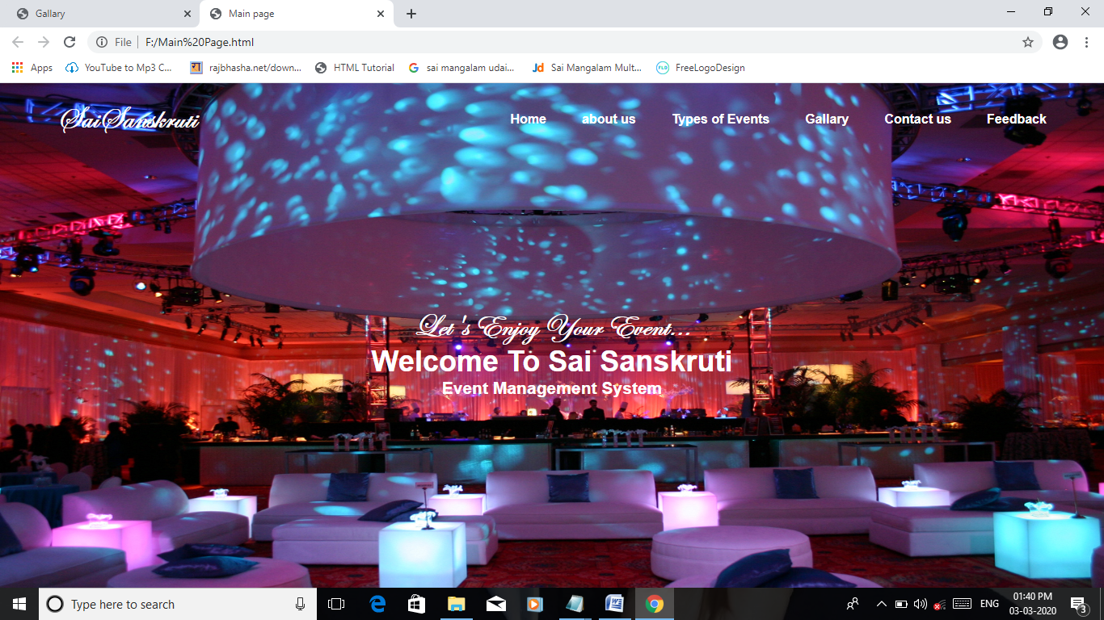

Home Page

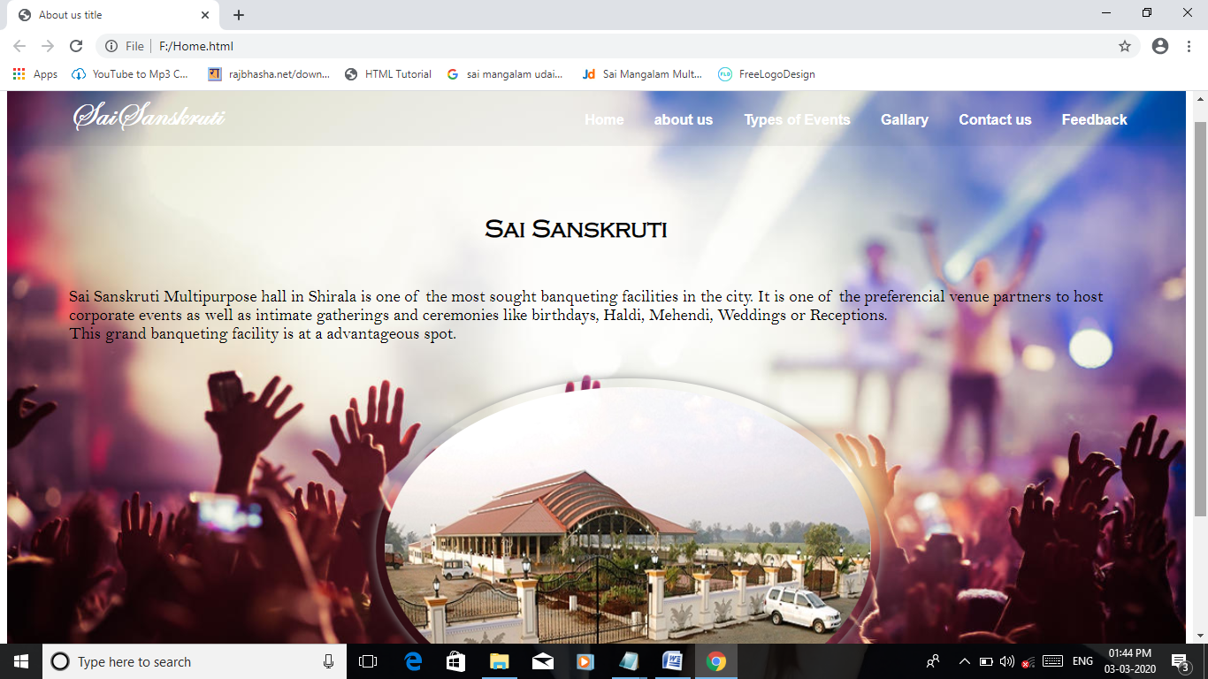

About Us

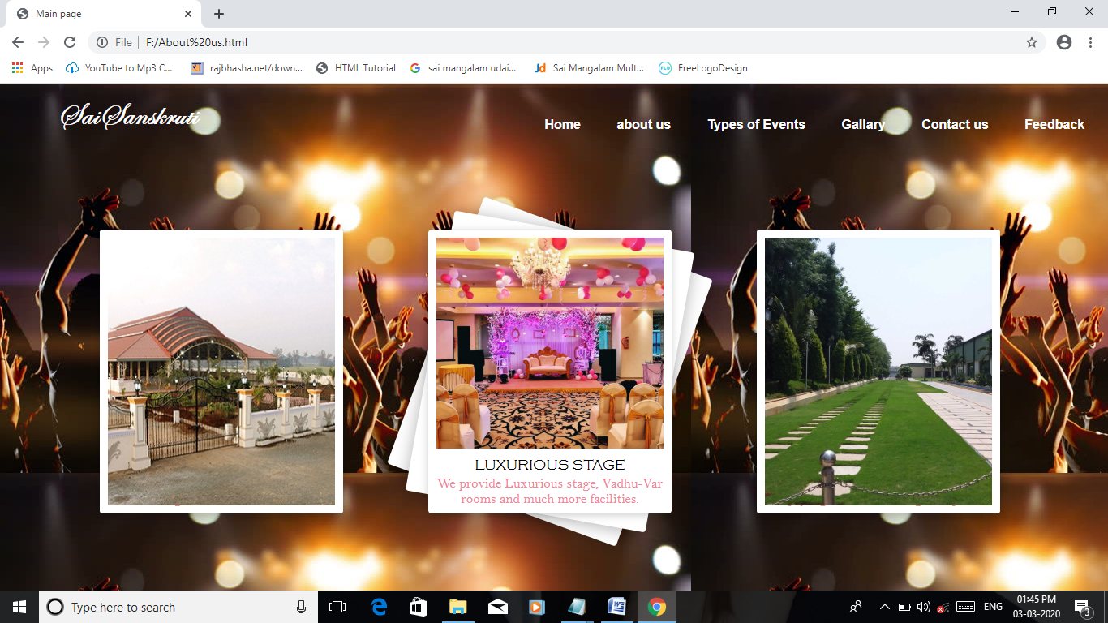

Types of Events

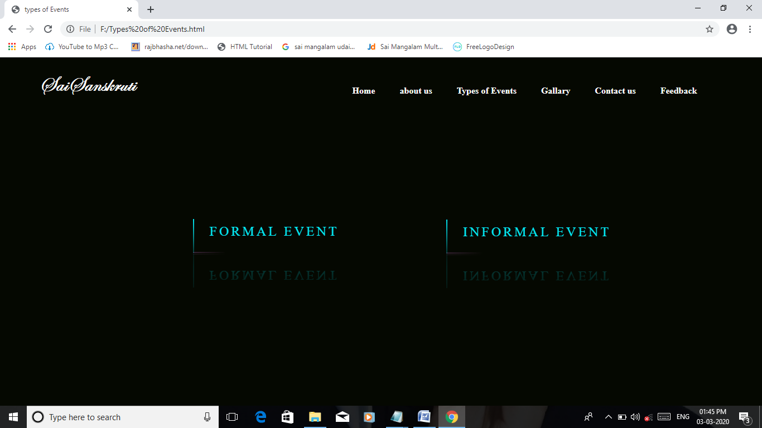

Formal Event

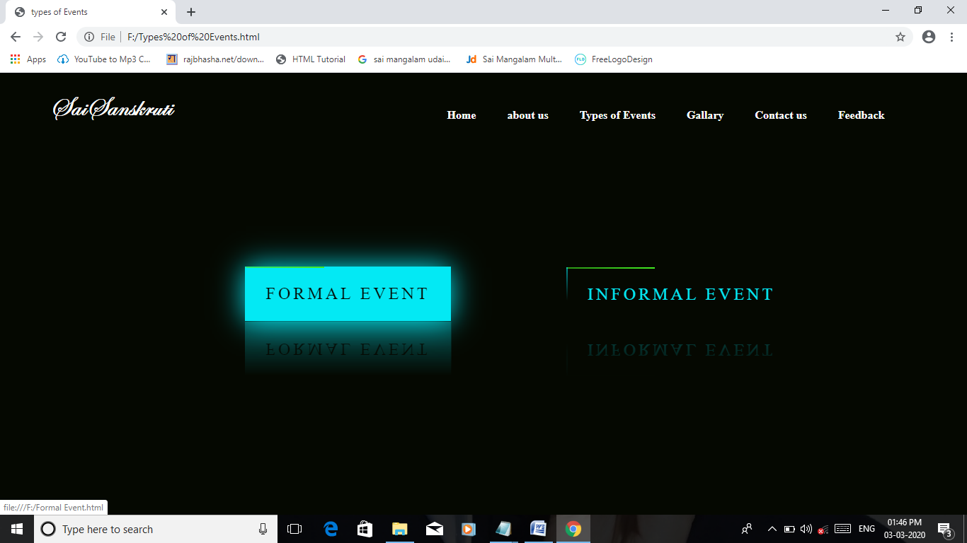

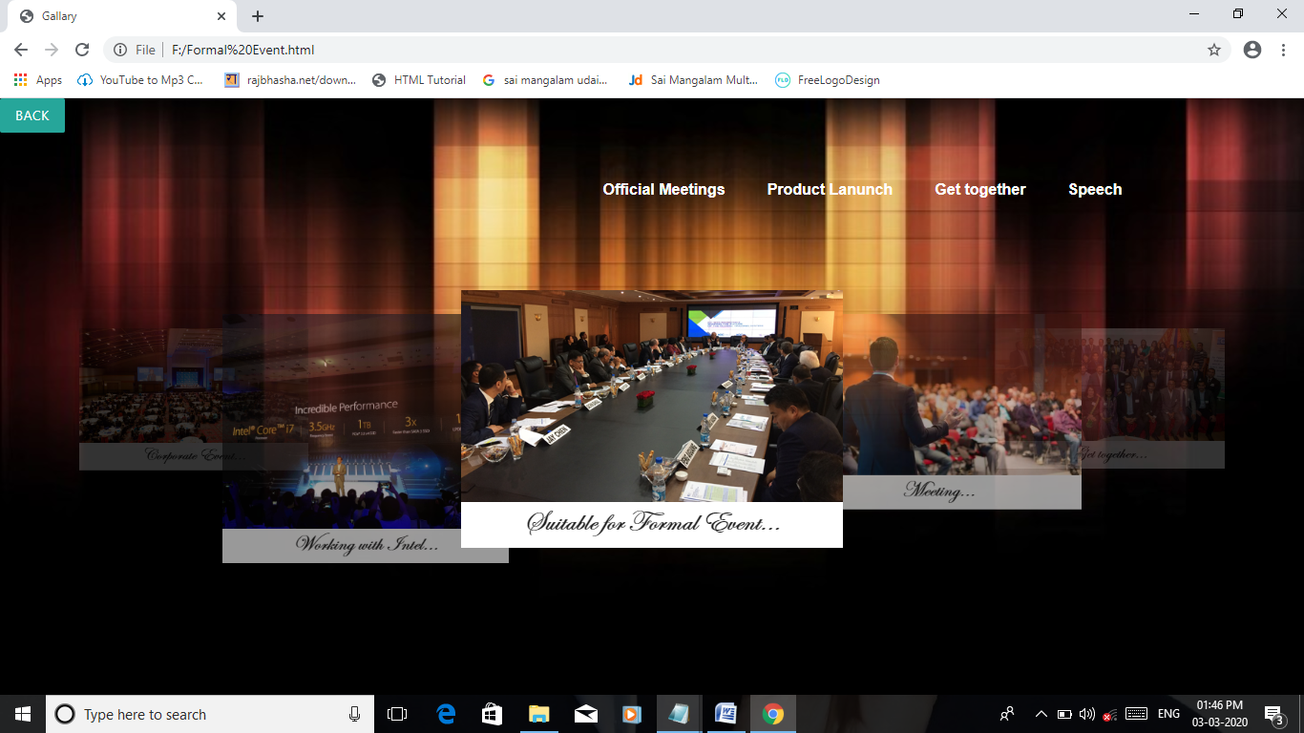

Official Meeting

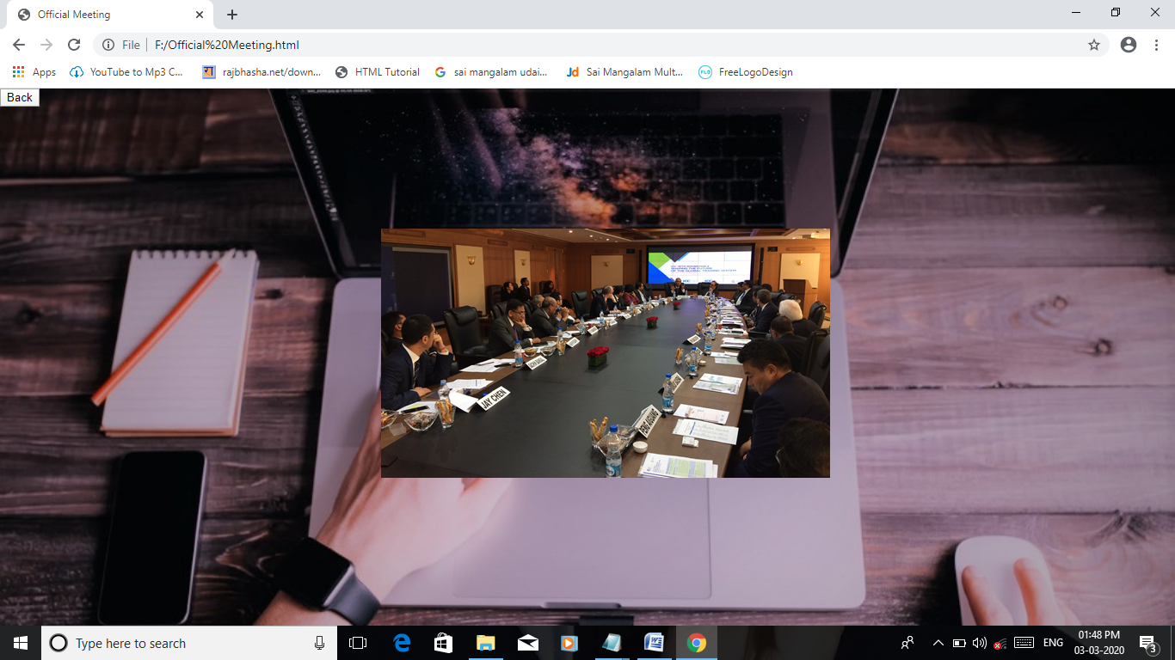

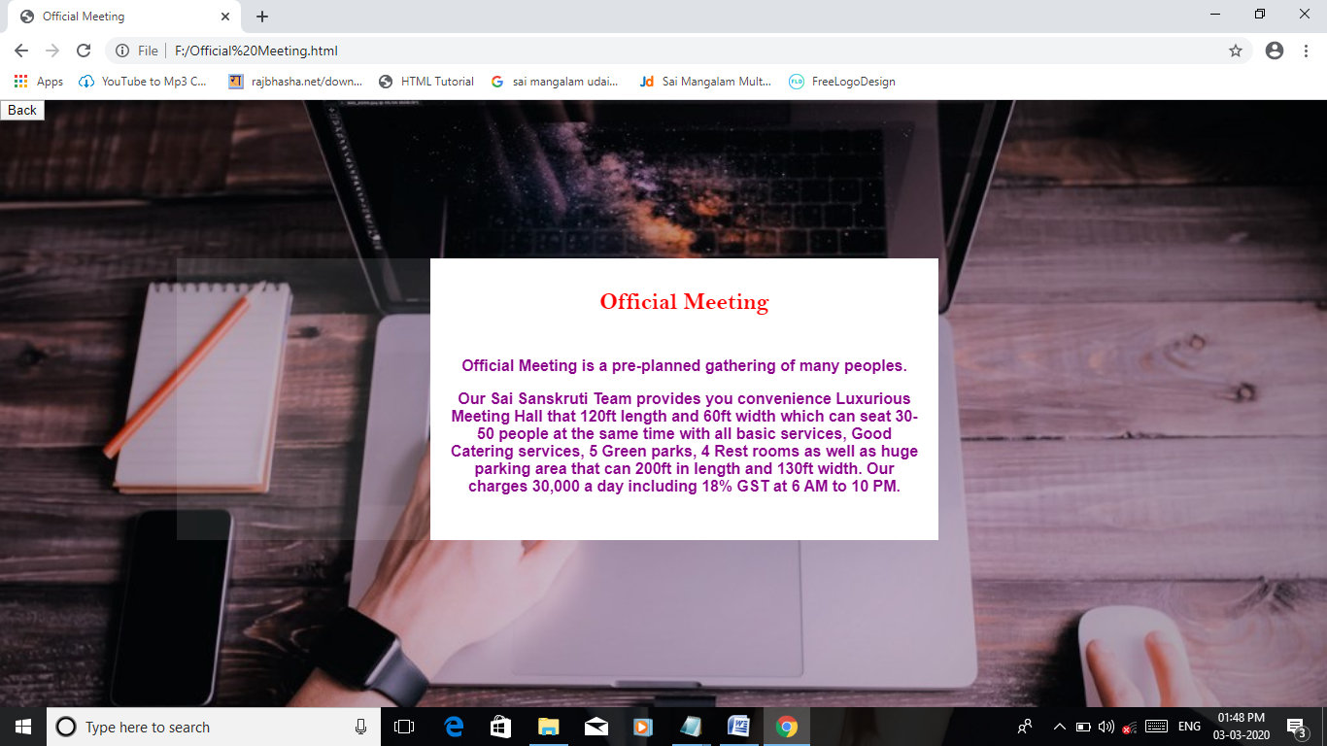

Product Launch

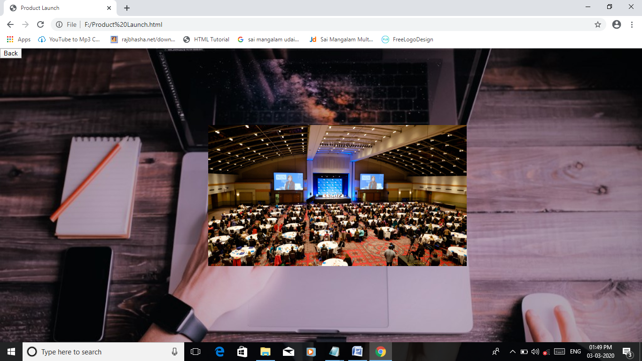

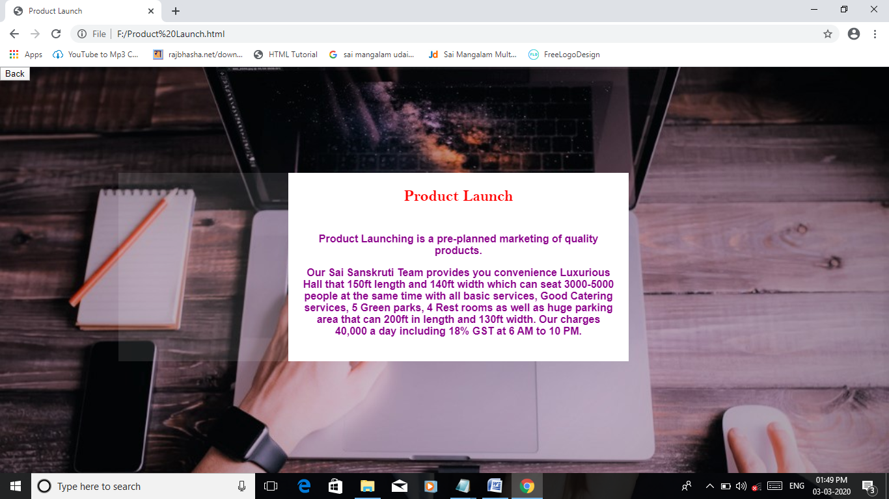

Get together

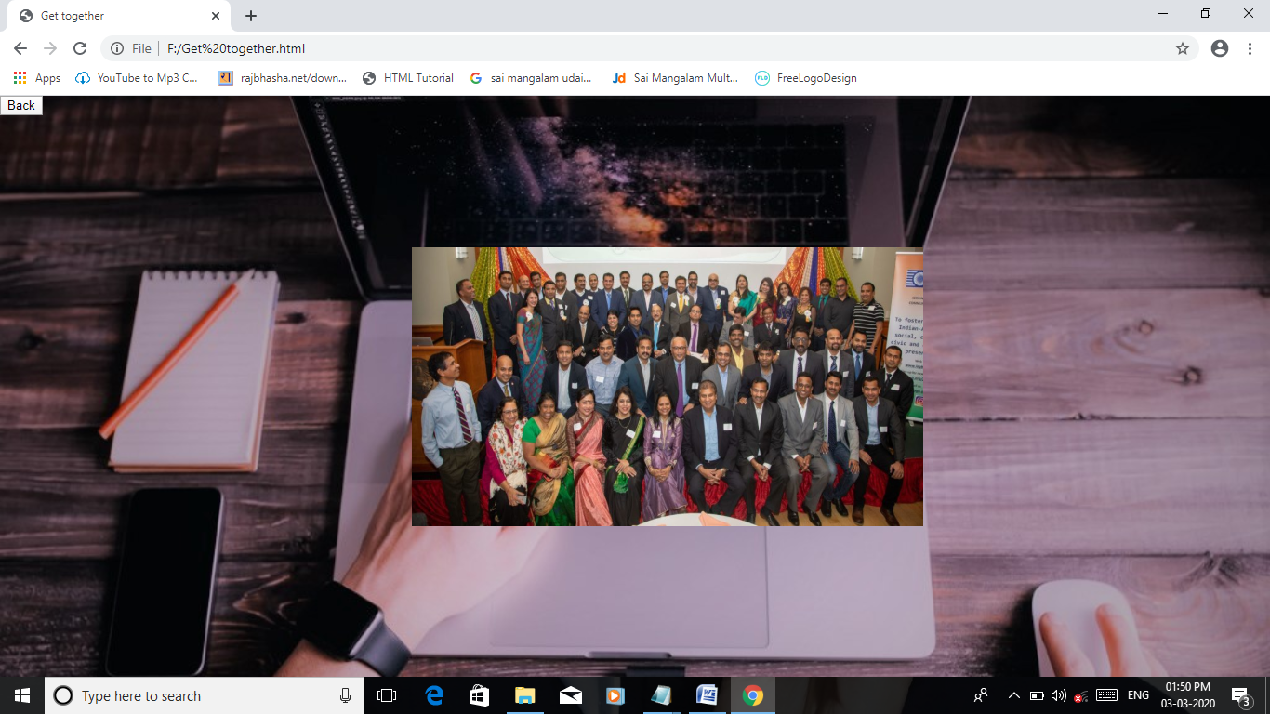

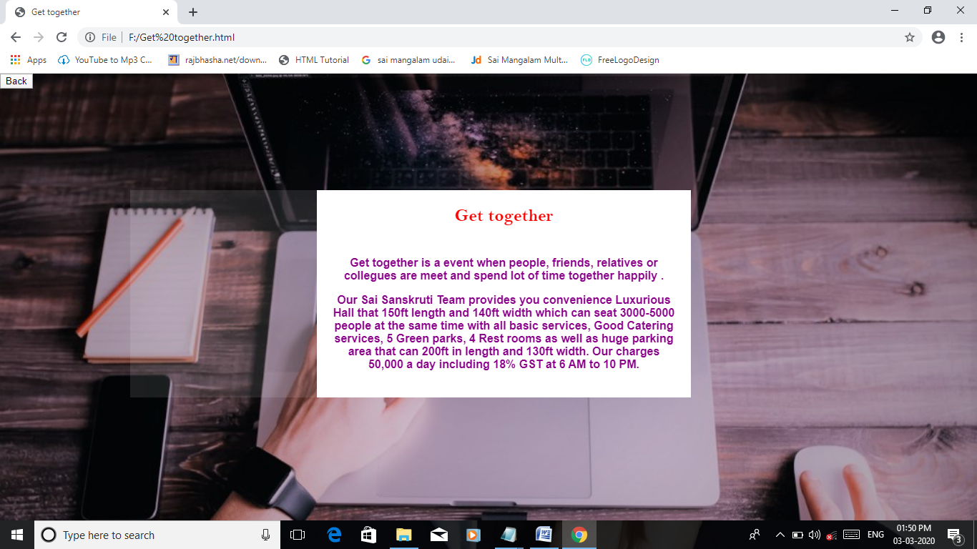

Speech

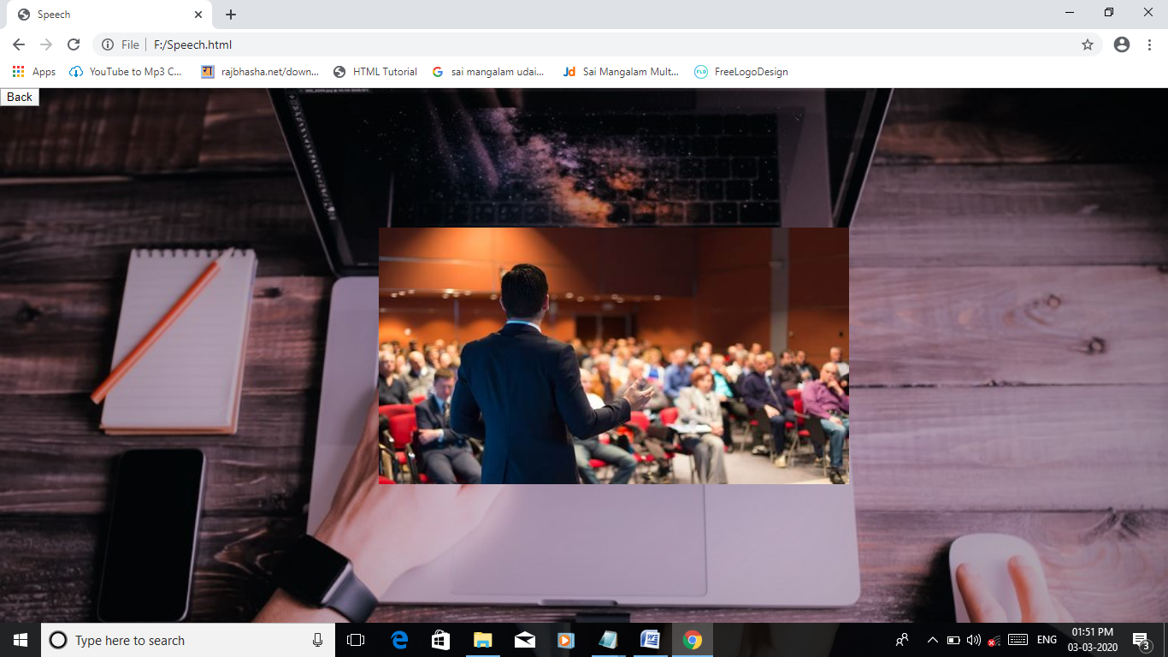

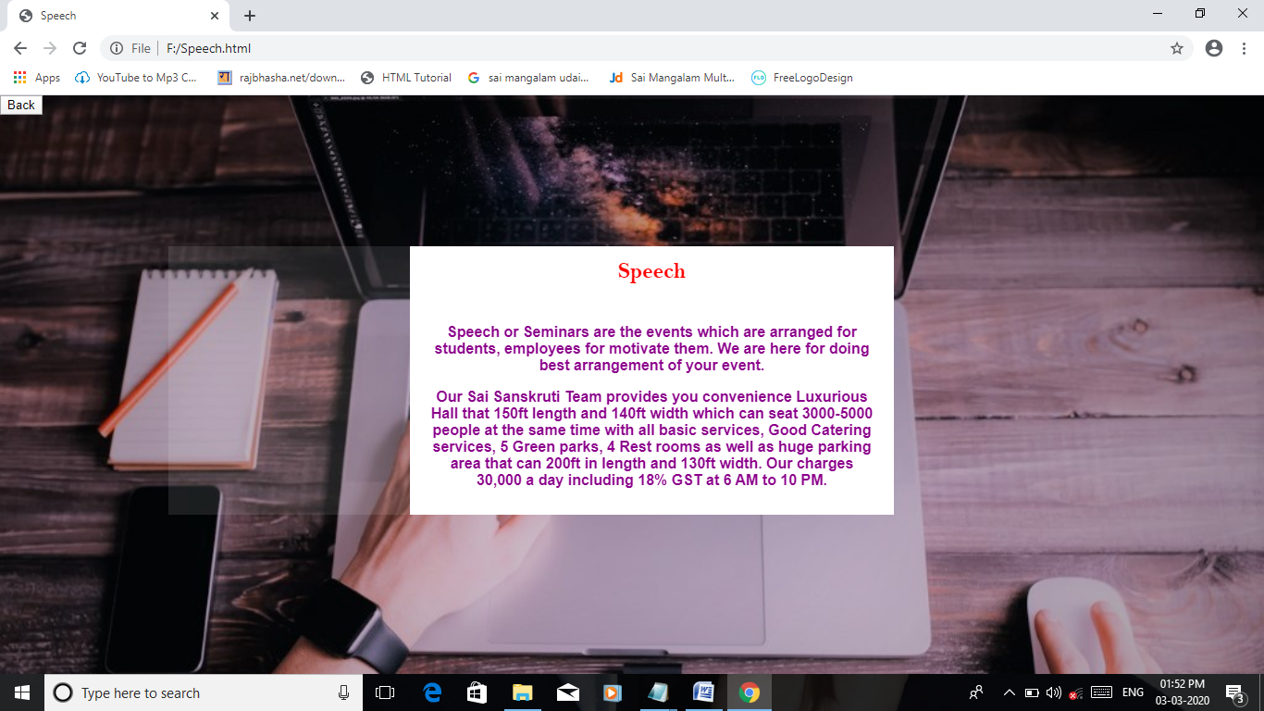

Informal Event

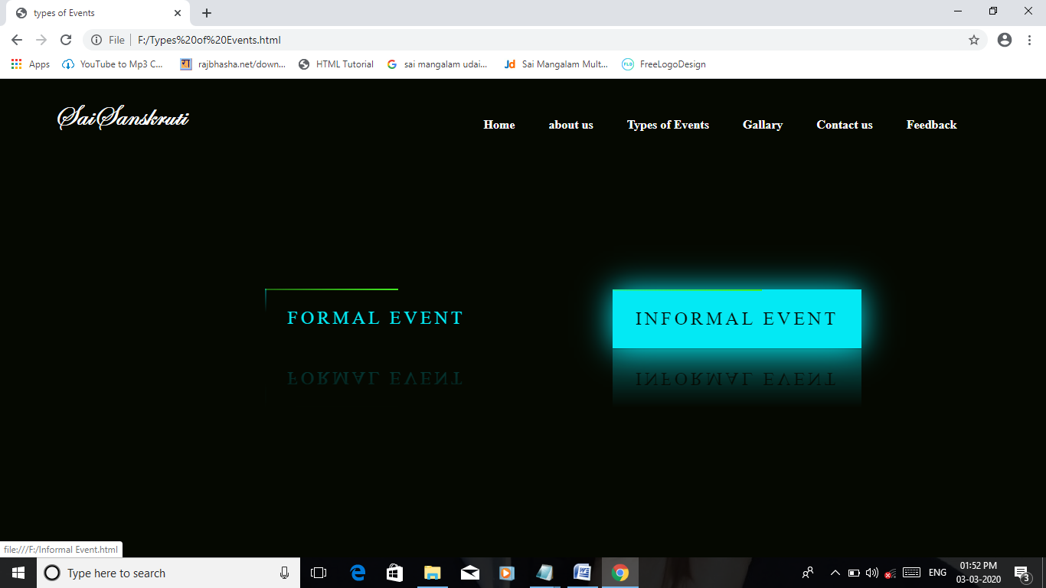

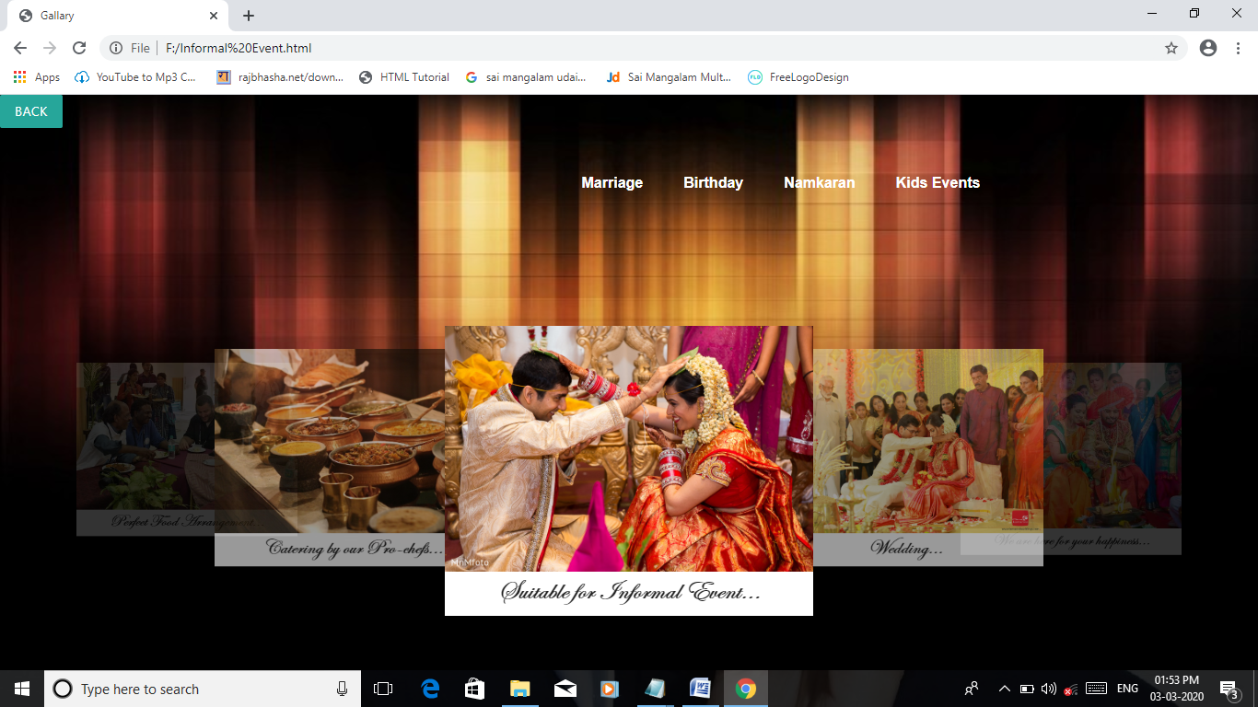

Marriage

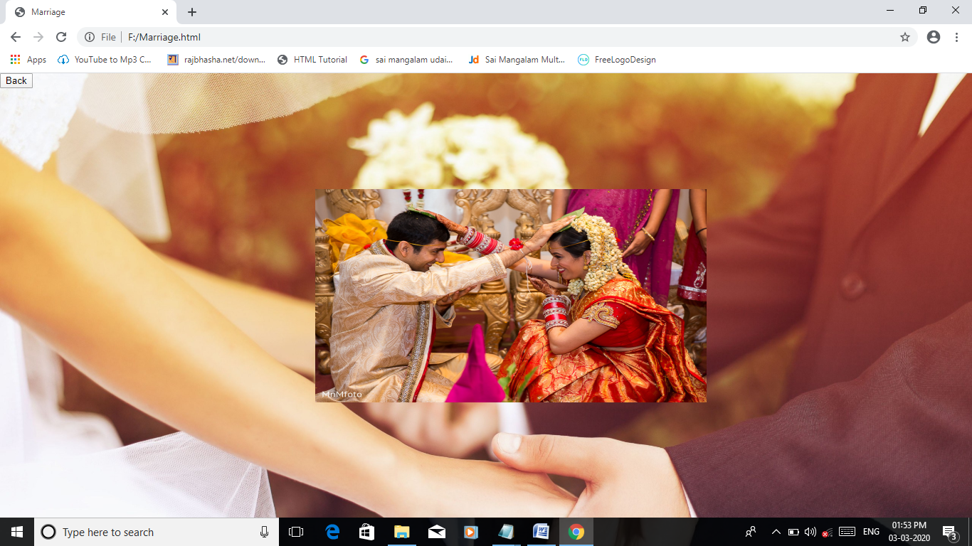

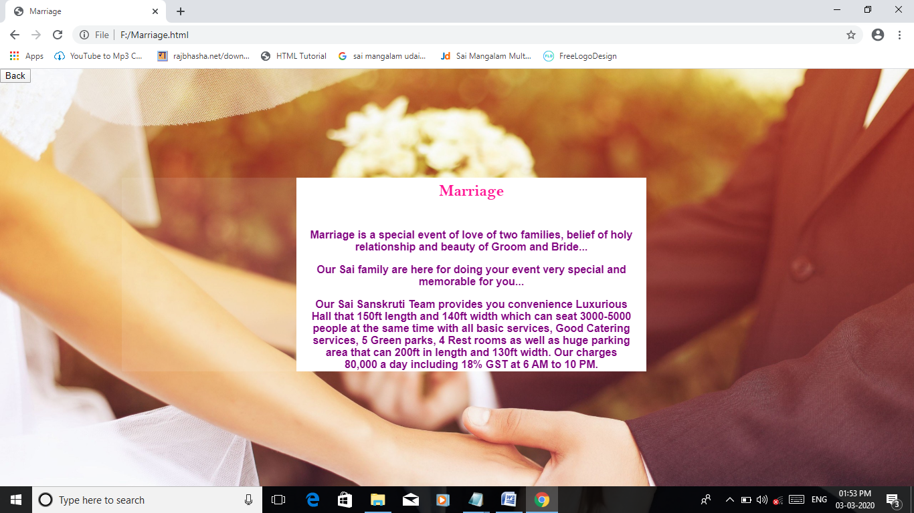

Birthday

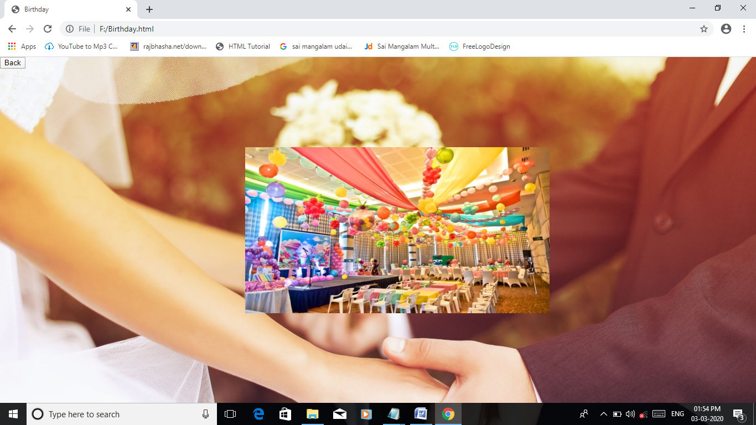

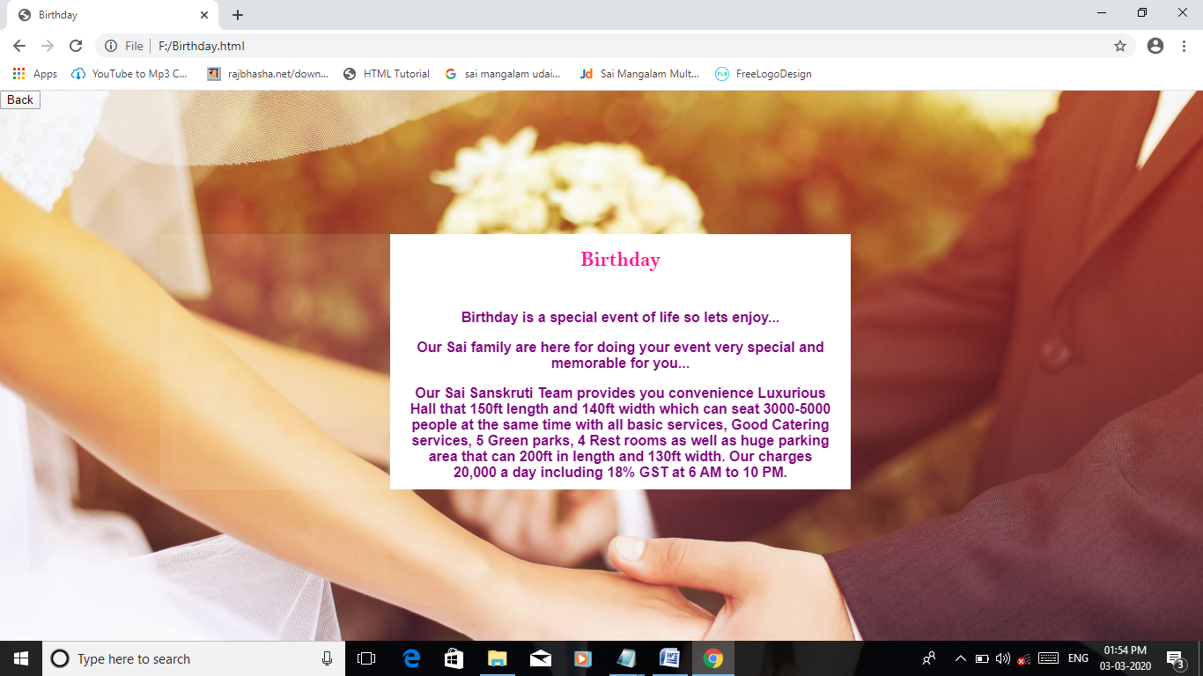

Namkaran

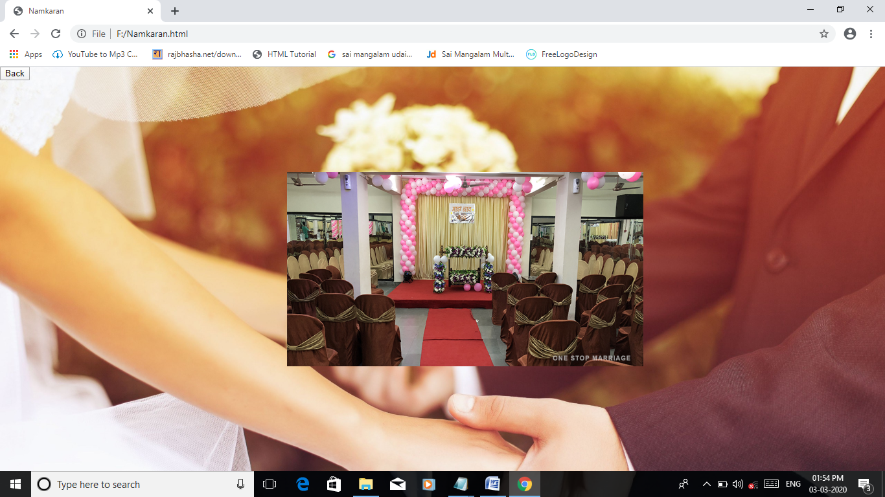

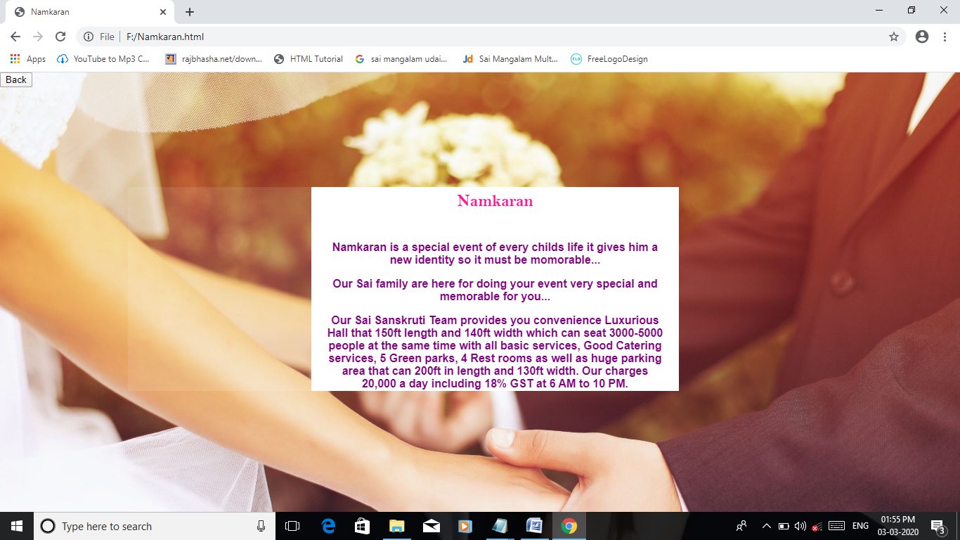

Kids Event

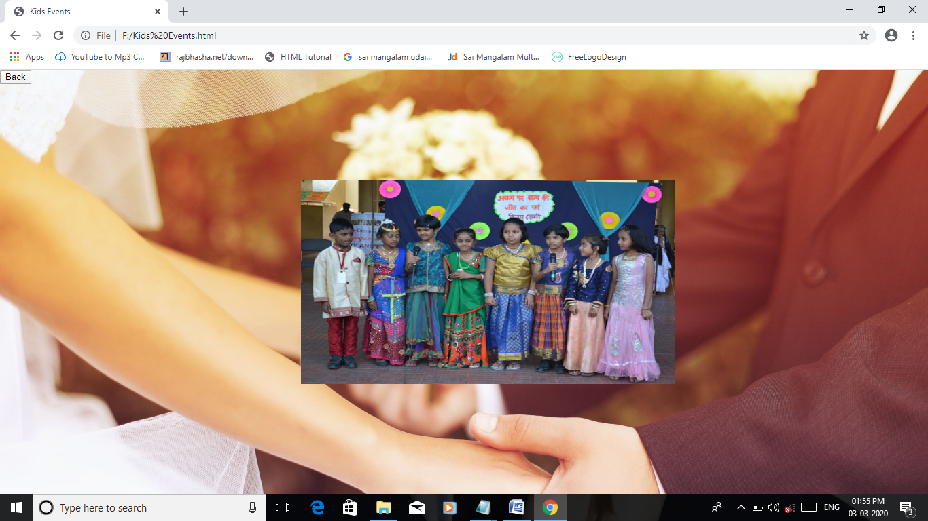

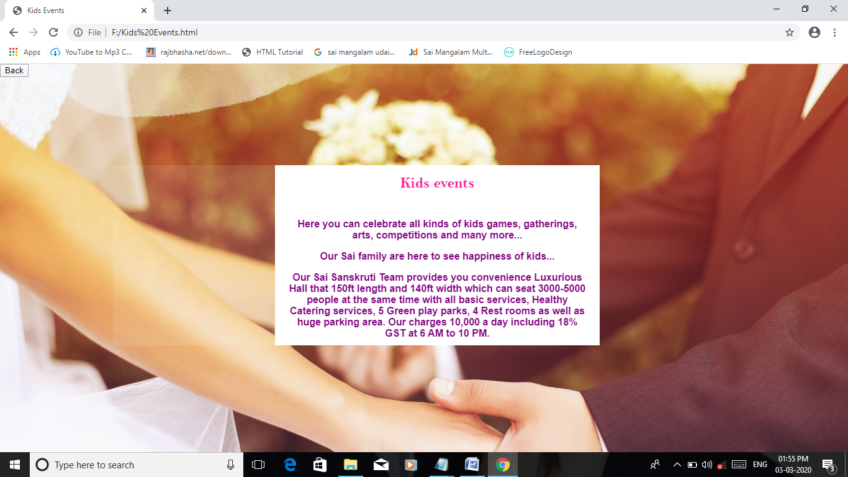

Gallery

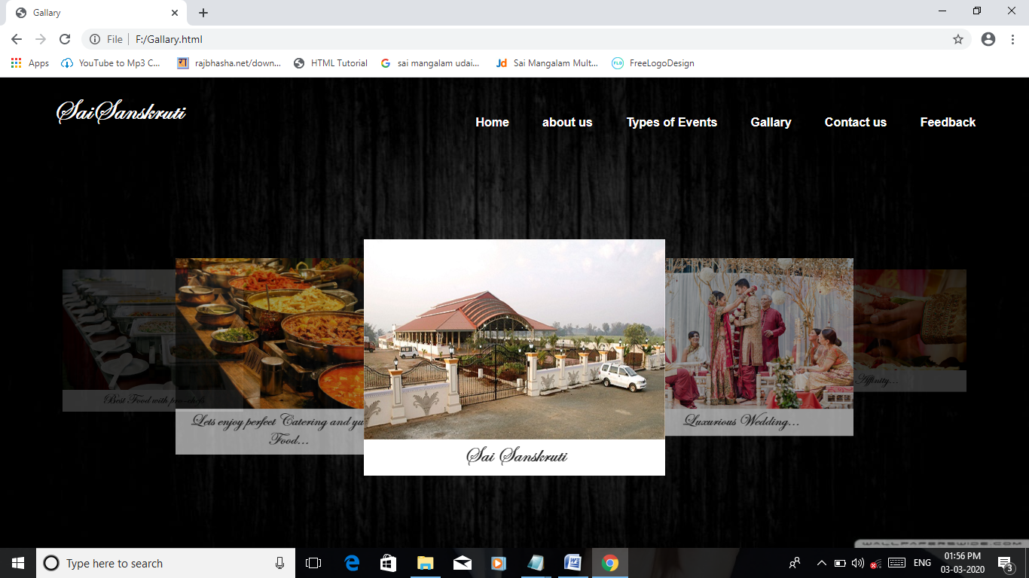

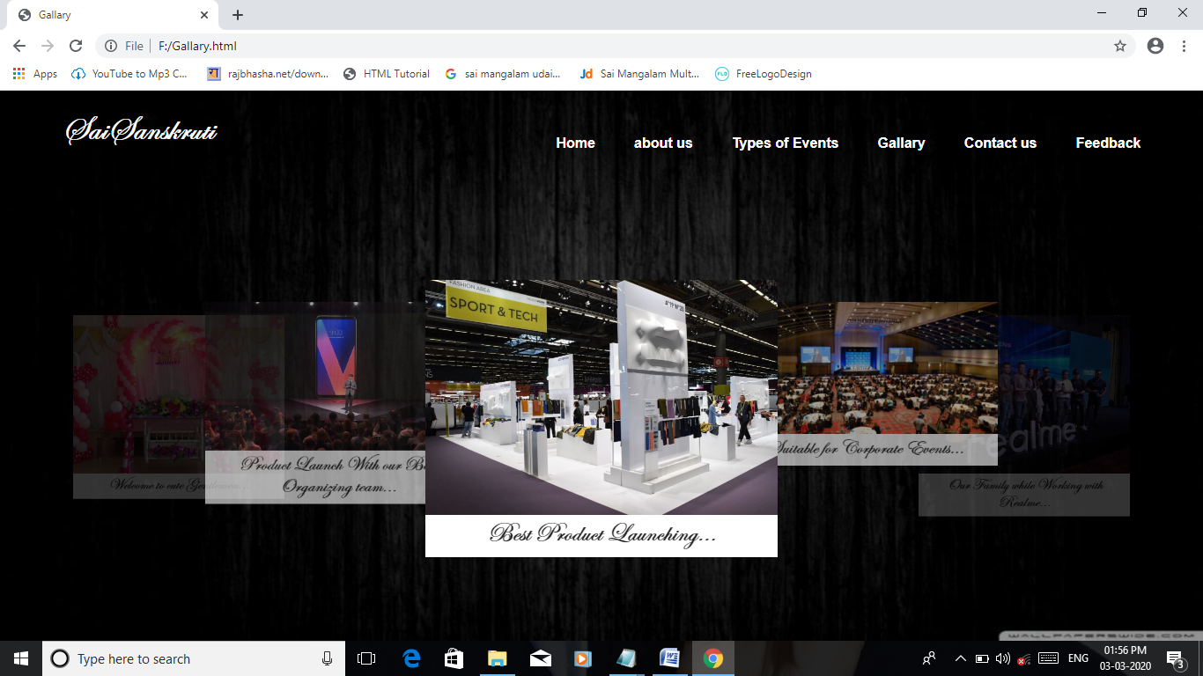

Contact Us

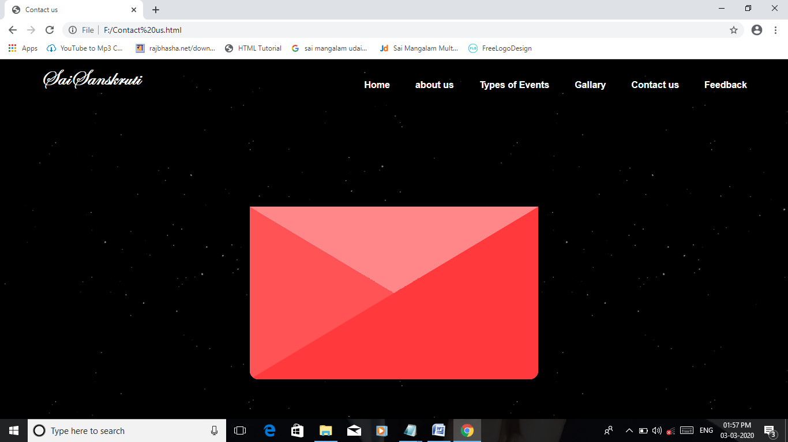

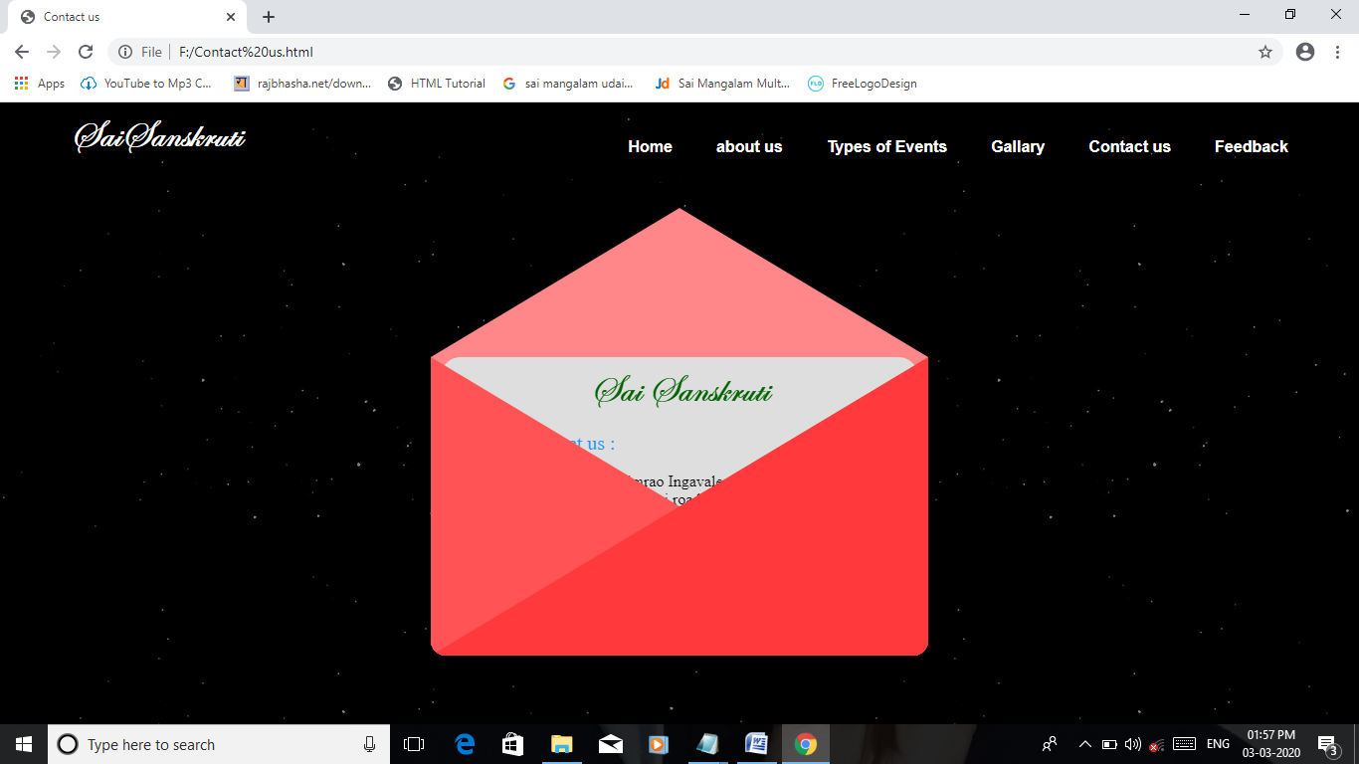

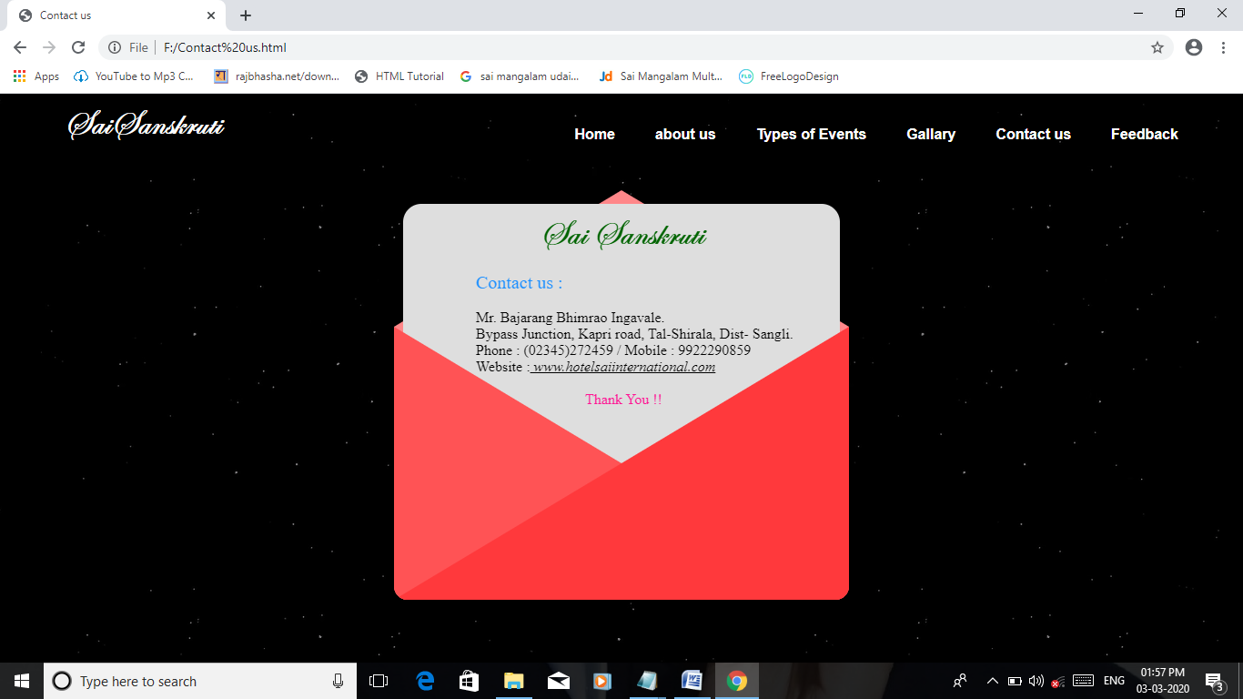

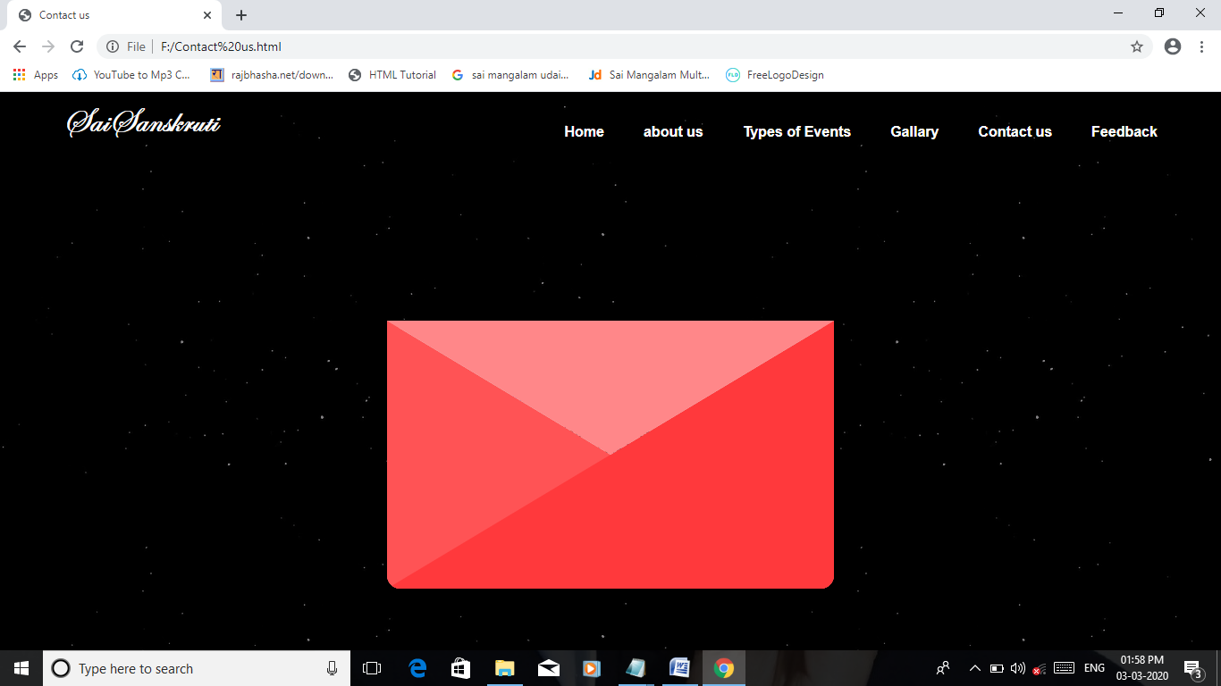

Feedback

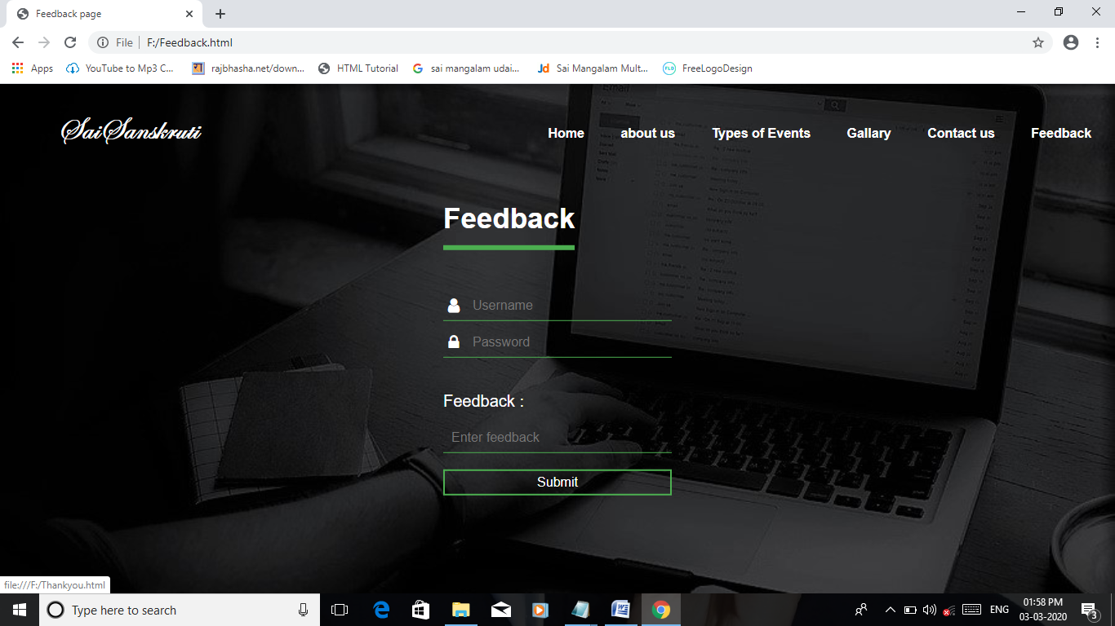

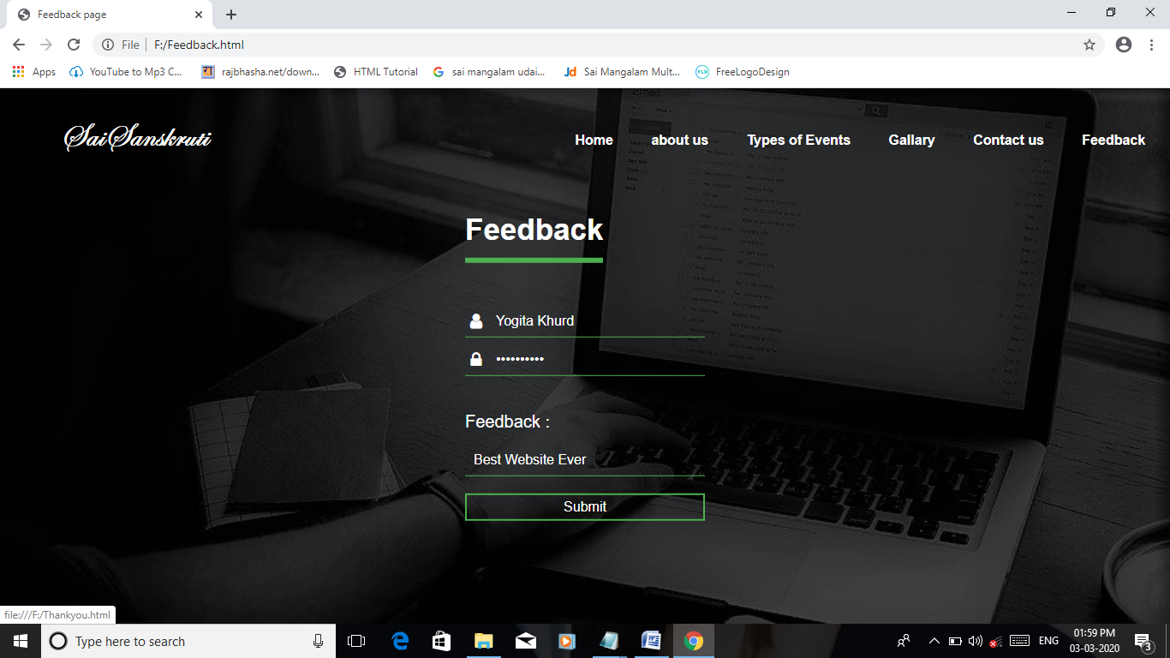

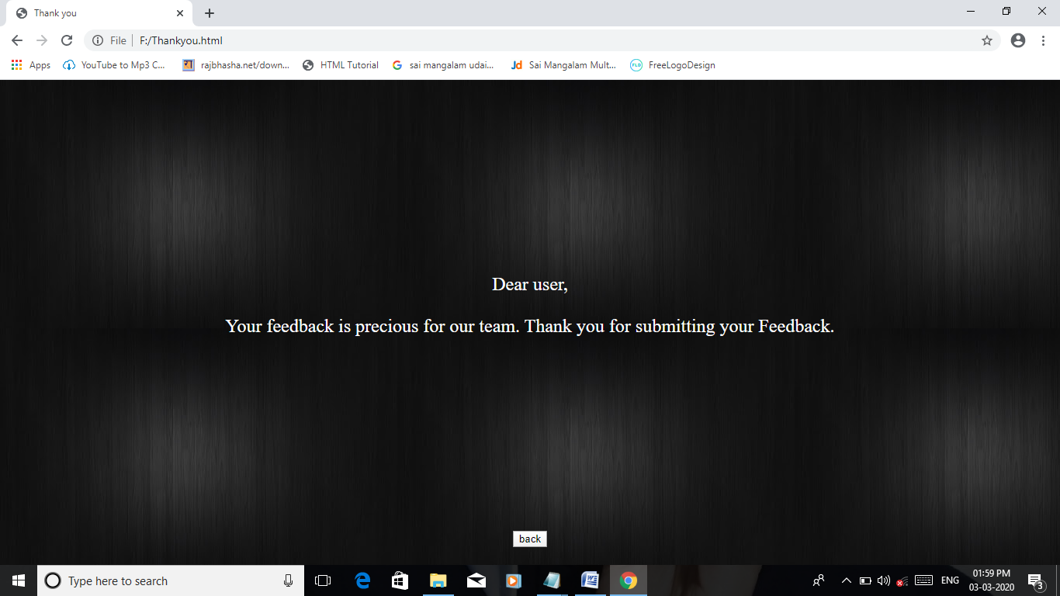

Chapter 7

CONCLUSION

CONCLUSION

The system is developed using HTML and CSS. It is very easy to handle any user can operate the system. The time saving is the main target behind it.

This system is very quick in action and require less time for processing. The main purpose of developing this system is any user can get information about Sai Sanskruti as well as services provided by us.

BIBLOGRAPHY

BIBLOGRAPHY

Books :-

* Web Technology –
* Uttam Roy.

Websites :-

* [www.W3schools.Com](http://www.W3schools.Com)
* [www.Google.Com](http://www.Google.Com)
* [www.Youtube.Com](http://www.Youtube.Com)